AP Statistics Notes – Chapter 7: Sampling Distributions

Section 7.1 Notes: Sampling Distributions Introduction

Chapter 7 is all about finishing up probability and connecting it to the topic of ____________________.

What is Inference?

Vocabulary Review:

Population: Parameter:

Sample: Statistic:

What types of parameters will we be estimating/inferring about?

- _____________________

  - We will use a _________ mean to estimate/draw conclusions about a __________ mean.

- ____________________________

  - We will use a _________ proportion to estimate/draw conclusions about a __________ proportion.

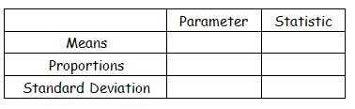
Notation:

So how do we accomplish estimating/drawing conclusions about a population parameter using sample statistics? The answer is by using a ______________________________________________!
What is a Sampling Distribution?

What is the purpose of a Sampling Distribution?

Types of Sampling Distributions
Example: We are interested in the proportion of WBHS seniors that have been accepted to college. So, I will find that proportion for this class. Since there is some variability with this sample, sample proportions from all the senior advisement classes will be used instead. Using all the sample proportions from each senior advisement, we can (very accurately) estimate the proportion of all seniors at WBHS that have been accepted to college.  - We are using several _________ to estimate one ______.  - The distribution consists of lots and lots of _____. | Example: We are interested in the average GPA of all WBHS juniors. So, I will find that average using the GPA of juniors in this class. Since there is some variability with this sample, sample averages from all junior advisement classes will be used instead. Using all the sample averages of GPAs from each junior advisement, we can (very accurately) estimate the average GPA of all juniors at WBHS.  - We are using several _________ to estimate one ______.  - The distribution consists of lots and lots of _____.

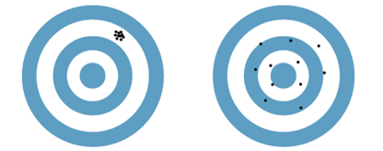
Sampling Distribution Goals:
- We don’t want our sampling distribution to be __________.
  - How is this goal accomplished?

- We want our sampling distribution to have a small amount
of ______________________.
  - How is this goal accomplished?

Side Note: We know sample size can affect the variability of a sampling distribution. Does the size of a population affect a sampling distribution??? RARELY.
Consider this example: Think of taking a sample scoop of M&Ms from a well-shuffled 1-pound bag. If the M&Ms are well shuffled does the scoop of M&Ms really know whether it was surrounded by a one-pound bag of M&Ms or a huge bin of M&Ms? Clearly it does not.

