AP Stat Lesson 1.3 – Describing with Quantitative Data Name:

4 steps to solving problems: 1) State 2) Plan 3) Do 4) Conclude
How do you find the mean?

What are the two notations for mean?
Sample mean Population mean

Let’s find the mean for the following stem – plot using the calculator.
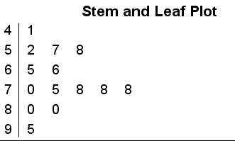
Key: $4\left|1\right.$ is a runner who races a 41 minute 10k.
Calc steps:
$$Stat→4→2nd 1 enter→Stat→edit →type in each value→Stat→calc→ 1-var stat→2nd 1 \left(L1 in List\right)→Freq List leave blank→Enter→Calculate→\overline{x} is the mean$$

Calculate the mean again without the outlier of 95. What do you notice?

What does the mean mean? Is the mean a resistant measure?

With the same numbers from above, find the median.

What is the median? Describe it. How do you find it?

Is the median a resistant measure? What does the median stand for in any context?

When a distribution is roughly symmetric, what do you know about the mean and median?

When the distribution is exactly symmetric, what do you know about the mean and the median?

In a skewed distribution, what do we know about the mean and the median? Draw a picture below.
Let’s measure spread/variability.
Given the following 18 quiz scores, find the following values.
20 55 60 60 65 65 70 70 70 75 80 80 80 85 85
85 90 100

Q1 Q3 IQR Context

Outliers – we have a formula!
Lower fence: Q1 – 1.5(IQR) Upper fence: Q3 + 1.5(IQR)

See if the above example has any outliers. Show the proof below.

Now let’s make a box plot. Below is the data for the Atlanta Falcons football team and the weight in pounds of the top 10 linemen on the team.
338 318 353 313 318 326 307 317 311 250

Find the 5 number summary first.

Then go to stat plot and turn on the box and whisker plot without outliers. Copy it below and label correctly.

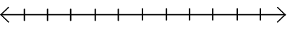

Now turn on the box and whisker plot with outliers. This is called a modified box and whisker plot. Copy it above and then jot down the 5 number summary. Did the numbers change at all from above?

What do you notice about both graphs? What changed from one graph to the next?

Standard deviation
The data provided is the number of pets owned by a group of 8 adults.
3 4 1 5 7 4 8 9
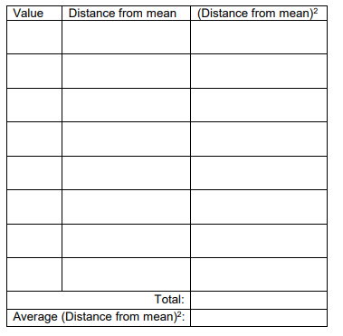
Find the mean of the data:

Write each value in the value column.

Take the value – mean in the 2nd column

Square that number to get the 3rd column

Add up the 3rd column and put that in the
total. Count up the number of values, take
1 less than it and divide the total by it.
That is the variance – average squared
distance from the mean

Variance – take the square root – Standard deviation – measures the average distance of the values from the mean.

Now let’s do it in the calc and see if we get the same thing. Type the values into L1 and follow the steps like we did before when we found 1 – variable stats. Scroll around. Look for the two symbols for standard deviation.

Population standard deviation Sample standard deviation

- Should only use std. deviation as a measure of spread when the mean is chosen as the center
- The sample std. deviation is always greater than or equal to 0.

- More spread out the values are, ______________________

- The standard deviation is _______________ to outliers.

Which measure of center is best?
Median IQR Mean Standard deviation

Let’s look at this data and see what we can figure out.
In 2017, AP Stat students asked “Who snaps more, male or females?” They asked a simple random sample of students from their school to record the number of snaps sent and received in a 2 week period.

Males | 127 | 44 | 28 | 83 | 0 | 6 | 78 | 6 | 5 | 213 | 73 | 20 | 214 | 28 | 11
Females | 112 | 203 | 102 | 54 | 379 | 305 | 179 | 24 | 127 | 65 | 41 | 27 | 298 | 6 | 130 | 0

What conclusions should the students draw? Give appropriate evidence to support your claims.

