AP Stat Histograms on the Calculator Name:

Many people believe that the distribution of IQ scores follows a “bell curve,” like the one shown below. But is this really how such scores are distributed? The IQ scores of 60 fifth grade students chosen at random from one school are shown below.

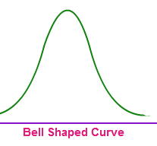
145 139 126 122 125 130 96 110 118 118
101 142 134 124 112 109 134 113 81 113
123 94 100 136 109 131 117 110 127 124
106 124 115 133 116 102 127 117 109 137
117 90 103 114 139 101 122 105 97 89
102 108 110 128 114 112 114 102 82 101

- Construct a histogram that displays the distribution of IQ scores effectively.

- Describe what you see. Is the distribution bell shaped?

