Algebra Milestone study guide

**Unit 1**

1. Which one of these is not a function?

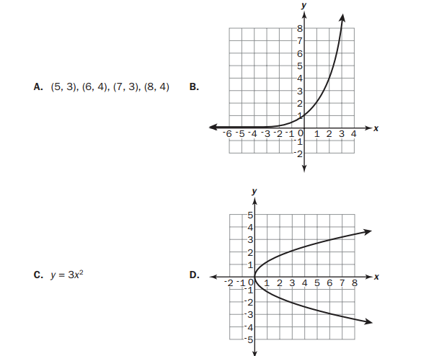

1. The number of school buses needed to transport students on a field trip is given by the function $f\left(x\right)=\frac{x+3}{30}$. What is the domain of the function?
   1. The set of all real numbers
   2. The set of all integers
   3. The set of all non-negative integers
   4. The set of all non negative real numbers
2. Rewrite the radical $-8\sqrt{726}$
$-88\sqrt{6}$

$-90.75$

$-986\sqrt{6}$

$-2,904$

3. Look at the expression $2\sqrt{8}*\sqrt{20}$. Which of the following is equivalent to it?
 $2\sqrt{28}$

  1. 5
$8\sqrt{10}$

$32\sqrt{10}$

4. Which sum is rational?
$π+18$

$\sqrt{25}+1.75$

$\sqrt{3}+5.5$

$π+\sqrt{2}$

5. What product is irrational?
$\sqrt{2}*\sqrt{50}$

$\sqrt{64}*\sqrt{4}$

$\sqrt{9}*\sqrt{49}$

$\sqrt{10}*\sqrt{8}$

6. A rectangle has a length of 12 meters and a width of 400 centimeters. What is the perimeter, in centimeters, of the rectangle?
   1. 824 cm
   2. 1600 cm
   3. 2000 cm
   4. 3200 cm
7. Jill swam 200 meters in 2 minutes and 42 seconds. If each lap is 50 meters long, which is MOST LIKELY to be her time, in seconds, per lap?
   1. 32 seconds
   2. 40 seconds
   3. 48 seconds
   4. 60 seconds
8. In which expression is the coefficient of term

“n” -1?

${3n}^{2}+4n-1$

$-n^{2}+5n+4$

$-{2n}^{2}-n+5$

${4n}^{2}+n-5$

1. The expression $s^{2}$ is used to calculate the area of a square, where s is the side length of the square. What does the expression ${(8x)}^{2}$ represent?
   1. The area of the square with side length of 8
   2. The area of the square with side length of 16
   3. The area of the square with side length of 4x
   4. The area of the square with side length of 8x
2. What is the product of 7x – 4 and 8x + 5 ?
   1. 15x + 1
   2. 30x + 2
${56x}^{2}+3x-20$

${56x}^{2}-3x+20$

3. A model of a house is shown. 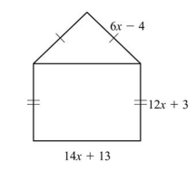

What is the perimeter, in units, of this model?

1. 32x + 12 units
2. 46x + 25 units
3. 50x + 11 units
4. 64x + 24 units
5. Which expression has the same value as $\left({8x}^{2}+2x-6\right)-({5x}^{2}-3x+2)$?
${3x}^{2}-x-4$

${3x}^{2}+5x-8$

${13x}^{2}-x-8$

${13x}^{2}-5x-4$

6. This equation is used to find h, the number of hours it will take Flo and Bryan to mow their lawn. $\frac{h}{6}+\frac{h}{3}=1$

How many hours will it take them to mow their lawn?

* 1. 6 hours
  2. 3 hours
  3. 2 hours
  4. 1 hour

1. For what values of x is the inequality $\frac{2}{3}+\frac{x}{3}>1$ true?
   1. X < 1
   2. X > 1
   3. X < 5
   4. X > 5
2. A ferry boat carries passengers back and forth between two communities on the Peachville River.

It takes 30 minutes longer for the ferry to make the trip upstream than downstream.

The ferry’s average speed in still water is 15 miles per hour.

The river’s current is usually 5 miles per hour.

This equation can be used to determine how many miles apart the two communities are.

$\frac{m}{15-5}=\frac{m}{15+5}+0.5$

What is m, the distance between the two communities?

1. 0.5 miles
2. 5 miles
3. 10 miles
4. 15 miles

**Unit 2**

1. Look at the steps used when solving 3(x – 2) = 3 for x. 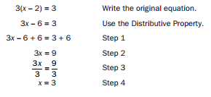

Which step is the result of combining like terms?

* 1. Step 1
  2. Step 2
  3. Step 3
  4. Step 4

1. Two lines are graphed on this coordinate plane. 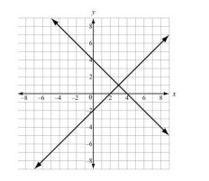

What point appears to be a solution of the equations of both of these lines?

* 1. (0, -2)
  2. (0, 4)
  3. (2, 0)
  4. (3, 1)

1. Based on the tables, at what point do the lines $y=-x+5$ and $y=2x-1$ intersect?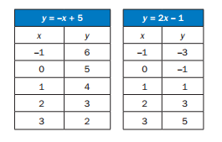
   1. (1, 1)
   2. (3, 5)
   3. (2, 3)
   4. (3, 2)
2. Look at the tables of values for two linear functions, f(x) and g(x). 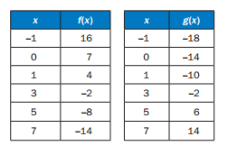

What is the solution to f(x) = g(x)?

1. Which ordered pair is a solution of
 $$3y+2=2x-5?$$

  1. (-5, 2)
   2. (0, -5)
   3. (5, 1)
   4. (7, 5)
2. A manager is comparing the cost of buying baseball caps from two different companies.

Company x charges a $50 fee plus $7 per baseball cap.

Company y charges a $30 fee plus $9 per baseball cap.

For what number of baseball caps will the cost be the same at both companies?

1. 10
2. 20
3. 40
4. 100
5. A shop sells one-pound bags of peanuts for $2 and three-pound bags of peanuts for $5. If 9 bags are purchased for a total cost of $36, how many 3 pound bags were purchased?
   1. 3
   2. 6
   3. 9
   4. 18
6. Which graph represents a system of linear equations that has multiple common coordinate pairs?

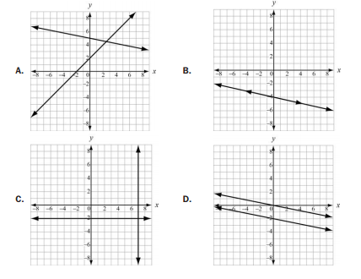

1. Which function represents the sequence?



* 1. f(n)= n + 3
  2. f(n) = 7n – 4
  3. f(n) = 3n +7
  4. f(n) = n + 7

1. Look at the sequences in this table.



Which function represents the sequence?

$a_{n}=a_{n-1}+1$

$a_{n}=a_{n-1}+2$

$a_{n}=2a_{n-1}-1$

$a_{n}=2a_{n-1}-3$

1. Consider this pattern. 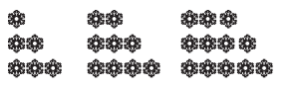

Which function represents the sequence that represents the pattern?

$a_{n}=a_{n-1}-3$

$a_{n}=a_{n-1}+3$

$a_{n}={3a}_{n-1}-3$

$a_{n}={3a}_{n-1}+3$

1. Which function is modeled in this table?

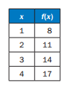

* 1. f(x) = x + 7
  2. f(x)= x + 9
  3. f(x) = 2x + 5
  4. f(x) = 3x + 5

1. Which explicit formula describes the pattern in this table?

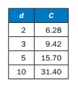

* 1. d = 3.14 x C
  2. 3.14 x C = d
  3. 31.4 x 10 = C
  4. C = 3.14 x d

1. If f(12 )= 4(12) – 20, which function gives f(x)?
   1. f(x) = 4x
   2. f(x) = 12x
   3. f(x) = 4x – 20
   4. f(x) = 12x – 20
2. A wild horse runs at a rate of 8 miles an hour for 6 hours. Let y be the distance, in miles, the horse travels for a given amount of time, x, in hours. This situation can be modeled by a function.

Which of these describes the domain of the function?

$0≤x≤6$

$0≤y≤6$

$0≤x≤48$

$0≤y≤48$

1. To rent a canoe, the cost is $3 for the oars and life preserver, plus $5 an hour for the canoe. Which graph models the cost of renting a canoe?

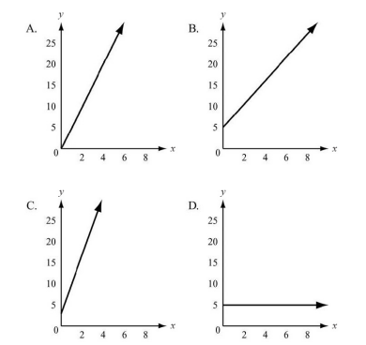

1. Juan and Patti decided to see who could read more books in a month. They began to keep track after Patti had already read 5 books that month. This graph shows the number of books Patti read for the next 10 days and the rate at which she read for the rest of the month. 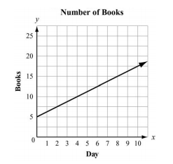

If Juan does not read any books before day 4 and he starts reading at the same rate as Patti for the rest of the month, how many books will he have to read by day 12?

* 1. 5
  2. 10
  3. 15
  4. 20

**Unit 3**

1. Which expression is equivalent to ${121x}^{2}-64y^{2}?$
   1. (11x – 16y)(11x + 16y)
   2. (11x – 16y)(11x – 16y)
   3. (11x + 8y)(11x + 8y)
   4. (11x + 8y)(11x – 8y)
2. What is the common factor for the expression ${ 24x}^{2}+16x+144$?
   1. 16
   2. 8x
 ${3x}^{2}+2x+18$

  3. 8(x – 2)(${3x}^{2}+9)$
3. Which of these shows the complete factorization of ${6x}^{2}y^{2}-9xy-42?$
 $3\left(2xy^{2}-7\right)(xy^{2}+2)$

 $\left(3xy+6\right)(2xy$ 1. −7)
$3\left(2xy-7\right)(xy+2)$

$\left(3xy^{2}+6\right)(2xy^{2}-7)$

4. What are the zeros of the function represented by the quadratic expression ${2x}^{2}+x-3$?
   1. x = -3/2 and x = 1
   2. x = -2/3 and x = 1
   3. x = -1 and x = 2/3
   4. x = -1 and x = -3/2
5. What is the vertex of the graph of $f\left(x\right)=x^{2}+10x-9$?
   1. (5, 66)
   2. (5, -9)
   3. (-5, -9)
   4. (-5, -34)
6. Which of these is the result of completing the square for the expression $x^{2}+8x-30$?
${(x+4)}^{2}-30$

$(x+4)^{2}-46$

$(x+8)^{2}-30$

$(x+8)^{2}-94$

7. The expression ${-x}^{2}+70x-600$ represents a company’s profit for selling x items. For which number(s) of items sold is the company’s profit equal to $0?
   1. 0 items
   2. 35 items
   3. 10 items and 60 items
   4. 20 items and 30 items
8. A garden measuring 8 feet by 12 feet will have a walkway around it. The walkway has a uniform width, and the area covered by the garden and the walkway is 192 square feet. What is the width of the walkway?
   1. 2 feet
   2. 3.5 feet
   3. 4 feet
   4. 6 feet
9. The formula for the area of a circle is $A=πr^{2}$. Which equation shows the formula in terms of r?
$r=\frac{2A}{π}$

$r=\frac{\sqrt{A}}{π}$

$r=\sqrt{\frac{A}{π}}$

$r=\frac{A}{2π}$

10. What are the solutions to the equation ${2x}^{2}-2x-12=0$?
    1. x = -4 and x = 3
    2. x = -3 and x = 4
    3. x = -2 and x = 3
    4. x = -6 and x = 2
11. What are the solutions to the equation ${6x}^{2}-x-40=0?$
    1. x = -8/3 and x = -5/2
    2. x = -8/3 and x = 5/2
    3. x = 5/2 and x = 8/3
    4. x = -5/2 and x = 8/3
12. What are the solutions to the equation $x^{2}-5x=14?$
    1. x = -7 and x = -2
    2. x = -14 and x = -1
    3. x = -2 and x =7
    4. x = -1 and x = 14
13. An object is thrown in the air with an initial velocity of 5 m/s from a height of 9 m. The equation $h\left(t\right)=-4.9t^{2}+5t+9$ models the height of the object in meters after t seconds. About how many seconds does it take for the object to hit the ground? Round your answer to the nearest tenth of a second.
    1. 0.940 second
    2. 1.50 seconds
    3. 2.00 seconds
    4. 9.00 seconds
14. The function $s\left(t\right)=vt+h-0.5at^{2}$ represents the height of an object, s, from the ground after the time, t, when the object is thrown with an initial velocity of v at an initial height of h and where a is the acceleration due to gravity (32 feet per second squared).

A baseball player hits a baseball 4 feet above the ground with an initial velocity of 80 feet per second. About how long will it take the baseball to hit the ground?

* 1. 2 seconds
  2. 3 seconds
  3. 4 seconds
  4. 5 seconds

1. A café’s annual income depends on x, the number of customers. The function $l\left(x\right)={4x}^{2}-20x$ describes the café’s total annual income. The function $C\left(x\right)={2x}^{2}+5$ describes the total amount the café spends in a year. The café’s annual profit, P(x) is the difference between the annual income and the amount spent in a year. Which function describes P(x)?
$P\left(x\right)={2x}^{2}-20x-5$

$P\left(x\right)={4x}^{3}-20x^{2}$

$P\left(x\right)={6x}^{2}-20x+5$

$P\left(x\right)={8x}^{4}-40x^{3}-20x^{2}-100x$

2. Which statement BEST describes the graph of

f(x + 6)?

* 1. The graph of f(x) is shifted up 6 units
  2. The graph of f(x) is shifted left 6 units
  3. The graph of f(x) is shifted right 6 units
  4. The graph of f(x) is shifted down 6 units

1. Which of these is an even function?
$f\left(x\right)={5x}^{2}-x$

$f\left(x\right)={3x}^{3}+x$

$f\left(x\right)={6x}^{2}-8$

$f\left(x\right)={4x}^{3}+{2x}^{2}$

2. Which statement BEST describes how the graph of $g\left(x\right)=-3x^{2}$ compares to the graph of $f\left(x\right)=x^{2}$?
   1. The graph of g(x) is a vertical stretch of f(x) by a factor of 3
   2. The graph of g(x) is a reflection of f(x) across the x-axis
   3. The graph of g(x) is a vertical shrink of f(x) by a factor of 1/3 and a reflection across the x-axis.
   4. The graph of g(x) is a vertical stretch of f(x) by a factor of 3 and a reflection across the x-axis.
3. A flying disk is thrown into the air from a height of 25 feet at time t=0. The function that models this situation is $h\left(t\right)=-16t^{2}+75t+25$, where t is measured in seconds and h is the height in feet. What values of t best describe the times when the disk is flying in the air?
   1. 0 < t < 5
   2. 0 < t < 25
   3. All real numbers
   4. All positive integers
4. Use this table to answer the question

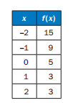

What is the average rate of change of f(x) over the interval $-2≤f\left(x\right)≤0?$

1. -10
2. -5
3. 5
4. 10
5. What is the end behavior of the graph of $f\left(x\right)=-0.25x^{2}-2x+1?$
   1. As x increases, f(x) increases

As x decreases, f(x) decreases

* 1. As x increases, f(x) decreases

As x decreases, f(x) decreases

* 1. As x increases, f(x) increases

As x decreases, f(x) increases

* 1. As x increases, f(x) decreases

As x decreases, f(x) increases

1. Use the graph to answer the question

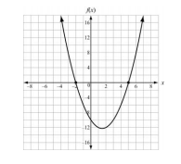

Which function is shown in the graph?

$f\left(x\right)=x^{2}-3x-10$

$f\left(x\right)=x^{2}+3x-10$

$f\left(x\right)=x^{2}+x-12$

$f\left(x\right)=x^{2}-5x-8$

1. The function $f\left(t\right)={-16t}^{2}+64t+5$ models the height of the ball that was hit into the air, where t is measured in seconds and h is the height in feet. This table represents the height, g(t), of a second ball that was thrown into the air. Which statement BEST compares the length of time each ball is in the air?

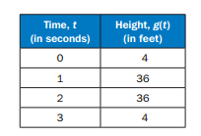

* 1. The ball is represented by f(t) is in the air for about 5 seconds and the ball is represented by g(t) is in the air for about 3 seconds.
  2. The ball represented by f(t) is in the air for about 3 seconds and the ball represented by g(t) is in the air for about 5 seconds
  3. The ball represented by f(t) is in the air for about 3 seconds and the ball represented by g(t) is in the air for about 4 seconds
  4. The ball represented by f(t) is in the air for about 4 seconds and the ball represented by g(t) is in the air for about 3 seconds

**Unit 4**

1. What explicit expression can be used to find the next term in this sequence?

2, 8, 18, 32, 50….

* 1. 2n
  2. 2n + 6

1. A certain population of bacteria has an average growth rate of 2%. The formula for the growth of the bacteria’s population is $A=P_{o}*1.02^{t}$ where Po is the original population and t is the time in hours.

If you begin with 200 bacteria, about how many bacteria will there be after 100 hours?

* 1. 7
  2. 272
  3. 1478
  4. 20000

1. Which function represents this sequence?
$f\left(n\right)=3^{n-1}$

$f\left(n\right)=6^{n-1}$

$f\left(n\right)=3{(6}^{n-1})$

$f\left(n\right)=6(3^{n-1})$

2. The points (0, 1), (1, 5), (2, 25) and (3, 125) are on the graph of a function. Which equation represents that function?
$f\left(x\right)=2^{x}$

$f\left(x\right)=3^{x}$

$f\left(x\right)=4^{x}$

$f\left(x\right)=5^{x}$

3. Which function shows the function $f\left(x\right)=3^{x}$ being translated 5 units to the left?
$f\left(x\right)=3^{x}-5$

$f\left(x\right)=3^{x+5}$

$f\left(x\right)=3^{x-5}$

$f\left(x\right)=3^{x}+5$

4. Which functions show the function $f\left(x\right)=3^{x}$ being translated 5 units down?
$f\left(x\right)=3^{x}-5$

$f\left(x\right)=3^{x+5}$

$f\left(x\right)=3^{x-5}$

$f\left(x\right)=3^{x}+5$

5. Consider the pattern. 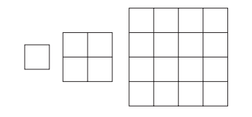

Which function represents the sequence that represents the pattern?

$a_{n}=4^{n-1}$

$a_{n}=4^{a_{n}-1}$

$a_{n}=a_{n}*4^{n-1}$

$a_{n}={(a_{n})}^{4}$

1. Which function is modeled in this table? 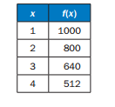
   1. 1000(0.80)
   2. 1000(0.20)
${1000(0.80)}^{x-1}$

$1000(0.2{0)}^{x-1}$

2. Which explicit formula describes the patter in this table?

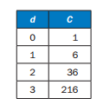

* 1. C = 6d
  2. C = d + 6

$C=6^{d}$

$C=d^{6}$

1. If $f\left(12\right)={100(0.50)}^{12},$ which expression gives f(x)?
$f\left(x\right)={12}^{x}$

$f\left(x\right)={100}^{x}$

$f\left(x\right)={100(x)}^{12}$

$f\left(x\right)=100(1{2)}^{x}$

2. A population of squirrels doubles every year. initially, there were 5 squirrels. A biologist studying squirrels created a function to meld their population growth: $P\left(t\right)=5(2^{t})$, where t is the time in years. The graph of the function is shown. 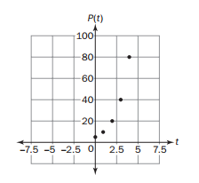

What is the range of the function?

* 1. Any real number
  2. Any whole number greater than 0
  3. Any whole number greater than 5
  4. Any whole number greater than or equal to 5

1. The function graphed on this coordinate gird shows f(x), the height of a dropped ball in feet after its xth bounce. 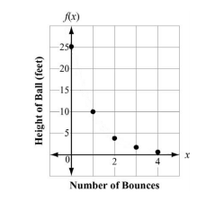

On which bounce was the height of the ball 10 feet?

* 1. Bounce 1
  2. Bounce 2
  3. Bounce 3
  4. Bounce 4

1. Look at the graph. 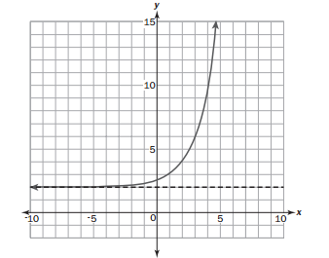

Which equation represents this graph?

$y=2^{x+1}-2$

$y=2^{x-1}+2$

$y=2^{x+2}-1$

$y=2^{x-2}+1$

1. Which scatter plot BEST represents a model of linear growth?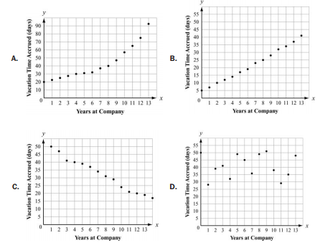
2. Which scatter plot BEST represents a model of exponential growth?

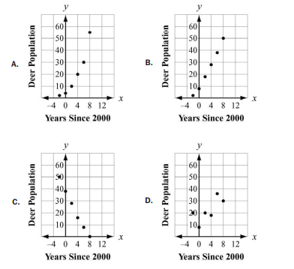

1. Which table represents an exponential function? 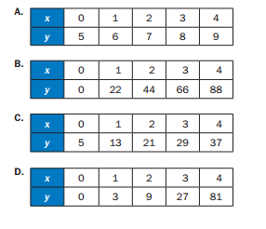
2. A table of values is shown for f(x) and g(x). 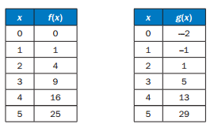

Which statement compares the graphs of f(x) and g(x) over the interval [0. 5]?

* 1. The graph of f(x) always exceeds the graph of g(x) over the interval of [0. 5]
  2. The graph of g(x) always exceeds the graph of f(x) over the interval [0. 5]
  3. The graph of g(x) exceeds the graph of f(x) over the interval [0. 4], the graphs intersect at a point between 4 and 5, and then the graph of f(x) exceeds the graph of g(x)
  4. The graph of f(x) exceeds the graph of g(X) over the interval [0, 4], the graphs intersect at a point between 4 and 5, and then the graph of g(x) exceeds the graph of f(x)

1. Which statement is true about graphs of exponential functions?
   1. The graphs of exponential functions never exceed the graphs of linear and quadratic functions
   2. The graphs of exponential functions always exceed the graphs of linear and quadratic functions
   3. The graphs of exponential functions eventually exceed the graphs of linear and quadratic functions
   4. The graphs of exponential functions eventually exceed the graphs of linear but not quadratic functions
2. Which statement BEST describes the comparison of the function values for f(x) and g(x)?

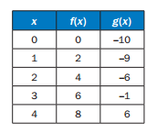

* 1. The values of f(x) will always exceed the values of g(x)
  2. The values of g(x) will always exceed the values of f(x)
  3. The values of f(x) exceed the values of g(x) over the interval [0,5]
  4. The values of g(x) begin to exceed the values of f(x) within the interval [4,5]

1. If a parent functions if f(x) = mx + b, what is the value of the parameter m for the line passing through the points (-2, 7) and (4, 3)?
   1. -9
   2. -3/2
   3. -2
   4. -2/3
2. If f(12) = 4(12) – 20, which function gives f(x)?
$f\left(x\right)={4x}^{2}-20$

$f\left(x\right)=4^{x}-20$

$f\left(x\right)=4x-20$

$f\left(x\right)={4x}^{2}+12x-20$

3. Look at the graph of the functions h(x) and p(x). 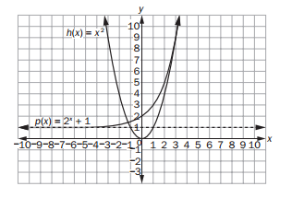

Which transformations of h(x) and p(x) translate each function so both pass through the point (0, 1)?

$h\left(x-1\right)=(x-{1)}^{2} and p\left(x+1\right)=2^{x+1}+1$

$h\left(x+1\right)=(x+{1)}^{2} and p\left(x-1\right)=2^{x-1}+1$

$h\left(x\right)-1=x^{2}-1 and p\left(x\right)+1=2^{x}+1$

$h\left(x\right)+1=x^{2}+1 and p\left(x\right)-1=2^{x}-1$

1. Look at the function f(x) and g(x).

$f\left(x\right)=x^{2}$ and $g\left(x\right)=2^{x}+3$

Which transformation of f(x) makes f(x)<g(x)?

1. f(-x)
2. –f(x)
3. ½*f(x)
4. 2f(x)
5. Which function is modeled in this table?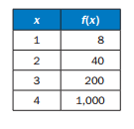
   1. f(x)=x + 7
   2. f(x)= 5x + 8
$f\left(x\right)=8^{x}$

$f\left(x\right)=\frac{8}{5}{(5)}^{x}$

6. Which function has a range of f(x) $≤\frac{3}{4}$?
$f\left(x\right)=\frac{3}{4}x+5$

$f\left(x\right)=-x^{2}+\frac{3}{4}$

$f\left(x\right)=x^{2}-\frac{3}{4}$

$f\left(x\right)=\frac{3}{4}-5x$

7. A sample of 1000 bacteria becomes infected with a virus. Each day, one fourth of the bacteria sample dies due to the virus. A biologist studying the bacteria models the population of the bacteria with the function $P\left(t\right)=1000(0.7{5)}^{t}$, where t is the time in days.

What is the range of this function in this context?

* 1. Any real number such that t $≥0$
  2. Any whole number such that t $≥0$
  3. Any real number such that $0≤P\left(t\right)≤1000$
  4. Any whole number such that $0≤P\left(t\right)≤1000$

1. The graph shows the height, y, in meters of a rocket above sea level in terms of the time, t, in seconds since it was launched. The rocket landed at sea level.

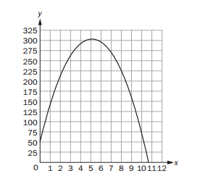

What does the x-intercept represent in this situation?

* 1. The height from which the rocket was launched
  2. The time it took the rocket to return to the ground
  3. The total distance the rocket flew while it was in flight
  4. The time it took the rocket to reach the highest point in its flight

1. The table defines a quadratic function.



What is the average rate of change between

x = -1 and x = 1?

* 1. Undefined
  2. -1/3
  3. -3
  4. -4

**Unit 6**

1. This table shows the average low temps in Fahrenheit, recorded in Macon GA and Charlotte, NC, over a six day period. 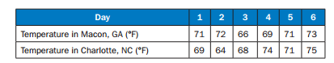

Which conclusion can be drawn from the data?

* 1. The interquartile range of the temps is the same for both cities
  2. The lower quartile for the temps in Macon is less than the lower quartile for the temps in charlotte
  3. The mean and median temps in Macon were higher than the mean and median temps in charlotte
  4. The upper quartile for the temps in charlotte was less than the upper quartile for the temps in Macon

1. A school was having a coat drive for a local shelter. A teacher determined the median number of coats collected per class and the interquartile range of the number of coats collected per class for the freshmen and sophomores.

* The freshmen collected a median number of coats per class of 10 and the interquartile range was 6
* The sophomores collected a median number of coats per class of 10 and the interquartile range was 4

Which range of numbers includes the third quartile of coats collected for both the freshmen and sophomores?

1. 4 to 14
2. 6 to 14
3. 10 to 16
4. 12 to 15
5. A reading teacher recorded the number of pages read in an hour by each of her students. The numbers are listed below:

44, 49, 39, 43, 50, 44, 45, 49, 51

For this data, which summary stat is NOT correct?

1. The min is 39
2. The lower quartile is 44
3. The median is 45
4. The max is 51
5. A science teacher recorded the pulse of each of the students in her classes after the students had climbed a set of stairs. She displayed the results, by class, using the box plots provided.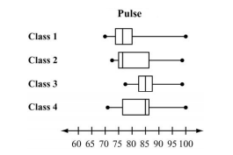

Which class generally had the higher pulse after climbing the stairs?

* 1. Class 1
  2. Class 2
  3. Class 3
  4. Class 4

1. Peter went bowling, Monday to Friday, two weeks in a row. He only bowled one game each time he went. He kept track of his scores below.

Week 1: 70, 70, 70, 73, 75

Week 2: 72, 64, 73, 73, 75

What is the BEST explanation for why Peter’s Week 2 mean scores was lower than his Week 1 mean score?

1. Peter received the same score three times in week 1
2. Peter had one very low score in week 2
3. Peter did not beat his high score from week 1 in week 2
4. Peter had one very high score in week 1
5. The functions f(x) = x – 9 is shifted 2 units up and 3 units to the left. Select the new function
   1. G(x) = 2x – 6
   2. G(x) = (x – 3) + 7
   3. G(x) = 3x – 7
   4. G(x) = (x+ 3) – 7
6. This histogram shows the frequency distribution of duration times for 107 consecutive eruptions of the Old Faithful geyser. The duration of an eruption is the length of time, in minutes, from the beginning of the spewing of water until it stops. What is the BEST description for the distribution?

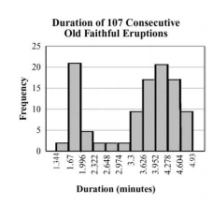

* 1. Bimodal
  2. Uniform
  3. Multiple outlier
  4. Skewed to the right

1. Which graph MOST clearly displays a set of data for which a quadratic function is the model of best fit?

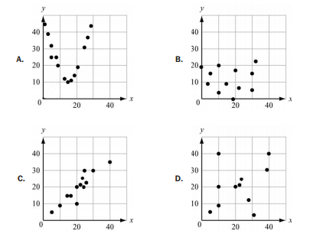

1. Which values is an irrational number?
$4+\sqrt{7}$

$\sqrt{2}\sqrt{8}$

$\frac{\sqrt{3}\sqrt{12}}{5}$

$\sqrt{3}-\sqrt{3}$

2. This graph plots the number of wins in the 2006 season and in the 2007 season for a sample of professional football teams.

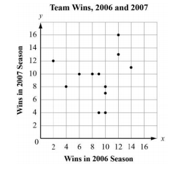

Which equation BEST represents a line that matches the trend of the data?

1. Y = x+ 2
2. Y = x+7
3. Y = 3/5x + 1
4. Y = 3/5x + 5
5. The graph plots the number of wins in the 2006 season and in the 2007 season for a sample of professional football teams.



Based on the regression model, what is the predicted number of 2007 wins for a team that won 5 games in 2006?

* 1. 4
  2. 7
  3. 8
  4. 12

1. Which BEST describes the correlation of the two variables shown in the scatter plot?

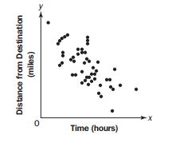

* 1. Weak positive
  2. Strong positive
  3. Weak negative
  4. Strong negative

1. Which of these statements is an example of causation?
   1. When the weather becomes winter, more meat is purchase at the supermarket
   2. More people go to the mall when students go back to school
   3. The greater the number of new television shows, the fewer the number of moviegoers
   4. After operating costs are paid at a toy shop, as more toys are sold, more money is made
2. To rent a carpet cleaner at a hardware store, there is a set fee and an hourly rate. The rental cost, c, can be determined using this equation when the carpet cleaner is rented for h hours.

c = 25 + 3h

Which of these is the hourly rate?

1. 3
2. 3h
3. 25
4. 25h

1. Sandra sells necklaces at a school craft fair. She uses the equation $P=7.5n-(2.25n+15)$ to determine her total profit at the fair. Based on this equation, how much does she charge for each necklace?
   1. $2.25
   2. $7.50
   3. $15.00
   4. $17.25
2. The perimeter of a rectangle is P = 2w + 2l where w is the width and l is the length. Rearrange the formula to find the width of the rectangular prism.
   1. W = P – 2l
   2. W = $\frac{P}{4-l}$
   3. W = 2P – l
   4. W = $\frac{P}{2-l}$
3. Vicky is studying French. She spends 1 hour reviewing each old chapter. She also spends 1.5 hours learning each new chapter. She spends at least 10 hours per week studying French. Which graph could represent the possible number of old chapters Vicky reviews, x, and the new chapters Vicky learns, y, each week?



1. Which function can be used to model the data in this table?
   1. F(x) = 3x
   2. F(x) = $\frac{x}{2}-1$
   3. F(x) = x – 1
   4. F(x) = 2x – 1
2. A scientist studied the relationship between the number of trees, x, per acre and the number of birds, y, per acre in a neighborhood. She modeled the relationship with a scatter plot and use the equation y = 4 + 6x for the regression line. What is the meaning of the slope and y – intercept of this regression line?
   1. The slope is 6. This means that the average number of birds per acre in an area with no tress is 6. The y intercept is 4. This means that for every 1 additional tree, she can expect an average of 4 additional birds per acre.
   2. The slope is 4. This means that for every additional tree, she can expect an average of 4 additional birds per acre. The y intercept is 6. The average number of birds per acre in an area with no tress is 6.
   3. The slope is 6. This means that for every additional tree, she can expect an average of 6 additional birds per acre. The y intercept is 4. The average number of birds per acre in an area with no trees is 4.
   4. The slope is 4. This means that the average number of birds per acre in an area with no trees is 4. The y intercept is 6. This means that for every 1 additional tree, she can expect an average of 6 additional birds per acre.
3. The total area of two rectangles can be represented by the expression (x)(3x + 1) + (2x)(x + 3). Which expression represents the total area of the two rectangles combine?
${7x}^{2}$

${6x}^{3}+{6x}^{2}$

${6x}^{2}+7x$

${5x}^{2}+7x$

4. A random group of high school students was surveyed. Each student was asked whether it should be mandatory for all high school students to participate in a sport. The results are partially summarized in the two way table.



In the freshmen group, what percentage of students agree that it should be mandatory for all students to participate in a sport?

* 1. 14.1%
  2. 22.6%
  3. 53%
  4. 73.6%