GSE Algebra 1 Unit 9 Test Review Name: ____________

Label the following as strong positive, strong negative, weak positive, weak negative or no correlation.
- r = -0.9
- r = 0.4
- r = -0.34
- r = -0.08
- r = 0.8760

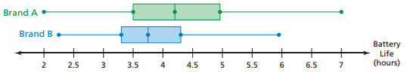
- What is the range of upper 75% of each brand?
- Which battery has a longer battery life?
- Which one has a higher median value of battery life?
- What is the IQR of Brand A? Brand B?

- What are the outliers of the following data, if any: 10 12 14 14 19 19 8 1 4 1

- Given the following data, list out the 5 number summary and create the box and whisker plot.
60 60 65 66 67 58 59 70

- As the number of people who carry umbrellas increases, the chance of rain goes up.
  - Correlation, no causation b. Correlation with causation c. No correlation

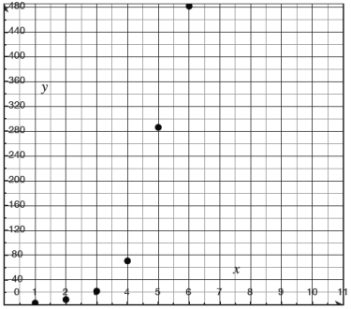
- What shape would best fit this data?

 | Own a Smart Phone | No Smart Phone | TOTAL
Own a Laptop | 60 |  | 95
Don’t own a Laptop | 27 | 18
TOTAL |  | 53 | 140

- What is the joint frequency of people who don’t own a smart phone and don’t own a laptop?
- How many people who do not own a laptop own a phone?
- How many people who own a phone own a laptop?
- What percentage of people own a laptop but not a phone?
- What is the probability of a person who does not own a smart phone owning a laptop?
- Draw the following:
  - Bimodal b. left skew c. right skew d. normal

Sam | 18 | 17 | 16 | 15 | 14
Nick | 12 | 13 | 12 | 14 | 14
- Find the MAD of Sam 21) Find the MAD of Nick 22) Who is more consistent? Why?

23) Find the median of the dot plot to the left.

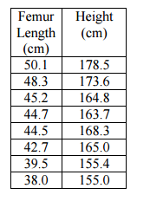
24) Find the line of best fit (linear regression model) for the following data.
a: ______________ b: ____________ r: ______________
remember, the equation is y = ax+b

25) Create a histogram, box and whisker plot and stem and leaf plot from the following data below.
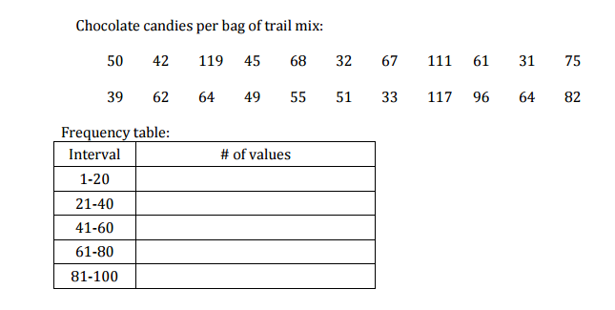

- For a data set the mean is 50.5 and the median is 48. There is an outlier of 12. If we took out the 12, the median would stay the same. What would happen to the mean?

- Given the following box and whisker plot, answer the following questions:
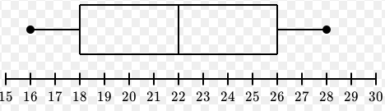
- What percent of data falls between 18 and 26?

- What percent of data falls above 26?

- What percent of data falls below 22?

- What percent of data falls above 16?

- What percent of data falls between 22 and 26?

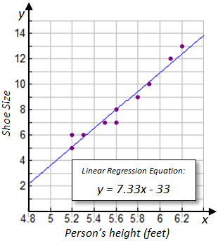
- Given the following linear regression line, answer the following questions:
  - Find a person’s shoe size when a person’s height is 6 feet.

  - Find a person’s shoe size when a person’s height is 5.5 feet.

  - Find a person’s height when their shoe size is 8.

  - Find a person’s height when their shoe size is a 4.5

- Given the following graphs, find each IQR. Then answer the questions.
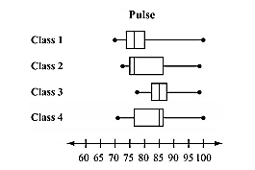Which one has the largest IQR? Which one has the smallest IQR?

- Label the following as categorical data or quantitative data.
  - Style of pants b. Color of shirts c. # of socks you own d. Size of pants

- # of pockets on pants f. Color of markers g. Length of the inseam of shorts

