GSE Algebra 1 Unit 7 Review Name: ________________
Show all work to get full credit!
- How has the following moved: $f\left(x\right)={(x+6)}^{2}$

- How does the following equation$g\left(x\right)=-3x^{2}$ compare to the graph of$f\left(x\right)=x^{2}$?

- Translate the function $f\left(x\right)=3^{x}$ 5 units to the left?

- Translate the function $f\left(x\right)=3^{x}$ 5 units down?

- Make the equation for the graph provided in vertex form.  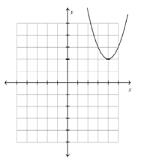 | - Make the equation for the graph provided (exponential). 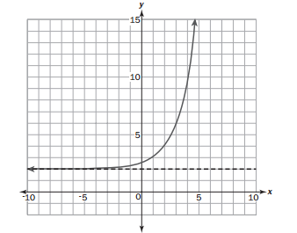
- Identify the equation $y=a{(1.6)}^{t}$ as exponential growth or decay. Then give the rate of growth or decay as a percent.

- The function f(x) = x – 9 is shifted 4 units up and 7 units to the left. Create the equation.

- What is the y-intercept for the following equation? Write the equation in vertex form then multiply out to put in standard form.  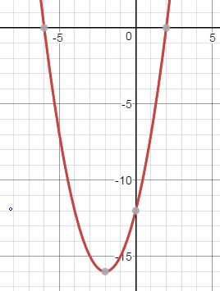 | - If the roots/x-intercepts of a quadratic function (parabola) are x = -3 and x = 3, what is the equation of the axis of symmetry?
- Make the equation in vertex form for the graph provided.  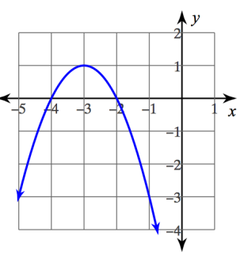 | - What is the vertex of the graph of  $f\left(x\right)=x^{2}+10x-9$? Write the equation in vertex form.
- Write the equation in intercept form. Then multiply out to standard form.
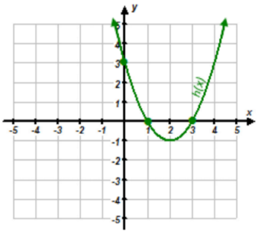

- Write a function that represents a quadratic after it has been translated up 3 units, reflected over the x-axis and vertically stretched 4 units.

- Write a function that represents an exponential decay with an asymptote of -3 and shifts left 2.

- Write a function that represents a line that has been horizontally stretched by a factor of 1/4, reflected about the x-axis, shifted left 2, and shifted down 7.

- How do you know if a quadratic has a maximum or a minimum?

- For the following, convert it to standard form. Then convert it to vertex form.
$$y=3(x-2)(x+4)$$

- Change $f\left(x\right)=3x^{2}-24x+5$ into vertex form AND state the vertex. Is the vertex a maximum or a minimum?

- You deposit $650 into an account that has 8% interest compounded semi-annually. What is the money worth
  - In 5 years? b. In 25 years?

- $f\left(x\right)=64(0.87)^{x}$
Initial amount | Ratio | Rate | Growth or Decay? | x = 13
- Graph the quadratic: $y=2x^{2}+4x-1$
y-int
vertex
Direction
Axis of symm
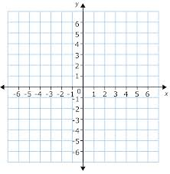

- Amy owns a graphic design store. She purchases a new printer to use in her store. The printer depreciates by a constant rate of 18% each year. The function $V=3700(1-0.18)^{t}$ can be use to model the value of the printer in dollars after t years.
- Explain what 3,700 represents in the equation of the function. | - What is the factor by which the printer depreciates each year?
- Amy also considered purchasing a printer that costs $4000 and depreciates by 25% each year. Which printer will have more value in 5 years? | - Amy wants to replace the original printer after 6 years. What is the cost of her printer after 6 years?
  - What would she have to sell the printer at to make a $200 profit?

- Joey and Jane were working on transformations together in Mrs. Jone’s class. Each of them came up with a different answer when given a transformation problem. Determine if either student is correct. Also, determine which aspects of each student’s answer is correct and/or incorrect (BE SPECIFIC!).

PROBLEM:
Write a function that represents an exponential growth that is vertically stretched by a factor of 2, reflects about the x-axis, shifts right 5, and shifts up 6.
Joey’s Answer:  $$y= -3{\left(2\right)}^{\left(x-5\right)}+6$$ |  | Jane’s Answer:  $$y= -\frac{1}{2}{\left(2\right)}^{\left(x+5\right)}+6$$
- Who is totally correct?  A) Joey b) Jane c) Neither | - What is correct about Joey’s answer and why?  What is incorrect about Joey’s answer and why? |  | - What is correct about Jane’s answer and why?  What is incorrect about Jane’s answer and why?

- Wh

- A super deadly strain of bacteria is causing the human population to decrease by 12% every day. There are currently 116,654 people still alive 60 days after the bacteria infected the public. How many people were there in the beginning?

