GSE Algebra 1 Unit 6 Review Name: _______________________________
Show all work! Be sure to read the directions. You are going to do great!!
- Graph the following quadratic given the table below. Then label the following.
- Vertex b) y-int c) Max/Min d) Axis of symmetry

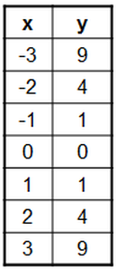

- For the following, list out all the characteristics provided.
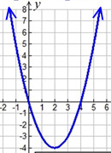
Dom: Range: Direc: Discr/Cont

Vertex: Axis of Symm: Max/min

x-ints: y-int: Function?

Incr: Decr: End Beh: $x→-∞$ $y→___$
$x→∞ y→____$

- Evaluate $f\left(x\right)=-x^{2}+3x+5 for the following x values$ (you need to plug ALL the numbers in)
- x = -2 b. x = 0 c. x = 2 d. x = 4

- Which of the following make $f\left(-3\right)=-2 true?$(plug in a -3 for x and see which one gives you -2)
- $f\left(x\right)=x^{2}+3x+2$ b. $f\left(x\right)=x^{2}+5x+4$

- $f\left(x\right)=x^{2}-3x-4$ d. $f\left(x\right)=(x+4)(x+1)$
- Consider the functions: f(x) = x ² + 2 g(x) = 3x
At what x value(s) are f(x) and g(x) the same? (Hint: make a table)

Which has a larger average rate of change (slope) from x = 3 to x = 5?

- Functions f(x) and g(x) are graphed below.
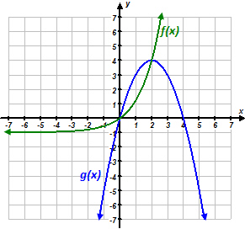
For which values of x is f(x) ˃ g(x)?
- x < 0 b. 0 < x < 2
- 0 < x < 4 d. x < 0 or x > 4

- For the following, find the slope from x = 5 to x = 20.
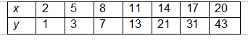

For # 8 – 11: Label the following as exponential, linear, quadratic or neither.
- 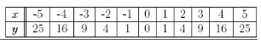 9)
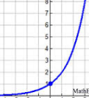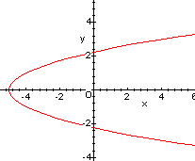

10) Mrs. DeLay has 20 gray hairs and every week, she adds 12 more?

11) Create a table that is neither linear, exponential, nor a quadratic!

Multiply out the following to put them in standard form.
- $2\left(x-3\right)(x+7)$ 13) $-5x(3x-8)$ 14) $(-4x-5)(9x+2)$

15) Given the following equation of a quadratic, list out all that you know.
$$y=(x+4)(x-2)$$

- x-ints: b. Standard form: c. y-int:

- direction: e. Domain: f. Max/Min:

- In class we have been talking about linear, exponential, and quadratic functions. I’d like you to write an explanation that explains the differences between a linear, an exponential, and a quadratic for the following:

Rate of Change:

Domain:

- Determine if the following are Linear, Quadratic, Exponential or all three:

_________________ My range is: $(-∞, ∞)$.

_________________ I can have 0, 1, or 2 x-intercepts.

_________________ I only have one end behavior.
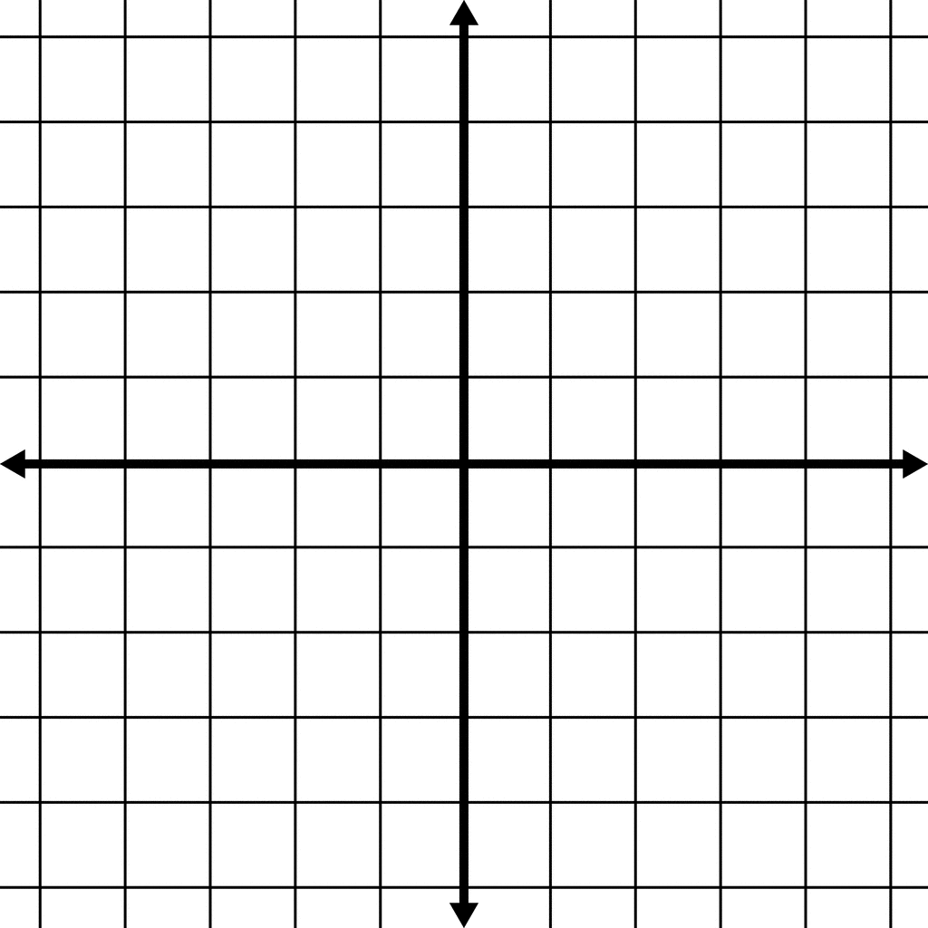

- Create a graph that contains the following information:

Domain: $(-∞, ∞)$ Range: $(-∞,4]$

Axis of Symmetry: x = 2 y-intercept: (0,0)

x-intercepts: (0,0) & (4,0)

