GSE Algebra 1 Unit 4 Test Review Name: __________

Show all work! No work, no credit
- Solve the following problem. Be sure to justify each step as you do it.
$$-3(x-3)=-27$$

Solve the following inequalities. Be sure to graph them on a number line.
- $-3x-22≤20$ 3) $4(x+3)>-12$ 4) $\frac{-2x}{7}-2≤6$

Solve the following equations for the specified variable.
- Solve for x: $\frac{ax-by}{c}=d$ 6) Solve for b: $a-b+c=3d$ 7) Solve for y:
$$4(2x-7y)=2(3x+13y)$$

Kameron is driving on a race-trac. He just completed lap 45. The fastest he will drive is 175 miles per hour. He will finish the race when he hits lap 300.
- What would be the inequality that represents his speed?

- Given the following inequality, tell what each part represents.
$$45+175x≤300$$

Amelia went on a road trip with some friends. She recorded the following information on the way to their destination:
- The trip took 3 hours - The car they took gets 30 miles per gallon. - 5 gallons of gas were used
- Her average speed was 50 miles per hour. - The price of gas was $3.00 per gallon

- How far away was their destination? (show your work)

- Are the following the same (equivalent)?
- $\frac{4x+6}{2}+3$ $2x+3$ b. $4(2x-5)$ $\frac{8x-20}{4}$ c. $\frac{-3(3x+1)}{3}$ $-3x-1$
- You are starting a business where you will pick up leaves in order to save up money to purchase yourself a new cell phone. The cell phone is $800. You already have $250 from last fall where you did the same thing. You charge $10.50 an hour. Write and solve the inequality that shows how many hours you need to work to make at least $800 so that you can afford the new phone.

- You want to know what you need to make on your next Algebra test in order to pass the class with at least a B. The averages that you have so far on the first 4 tests are 76, 73, 83 and a 91. What would be the average that you have to make on the 5th test to complete this task?

Write the inequalities and intervals that go with these number lines.
- 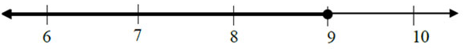 Interval: Inequality:

- 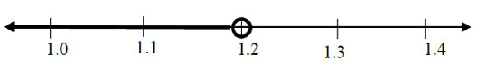 Interval: Inequality:

- 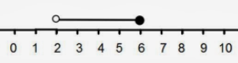 Interval: Inequality:

Solve the following equations for y (slope intercept form)
- $2(3x-4y)=17$ 18) $2y-12x=24$ 19) $x-3y=1$

Which one is larger? How do you know?
- Given: $-3x-15>-6$ 19) Given: x < y
x or -2 $x-y or y-x$

- Are the values given part of the solution set for the following: $-2x-4>-12$
- x = 2 and x = 3 b. x = 4 and x = 10 c. x = -2 and x = 14 d. x = 1 and x = 0

- Solve the following inequality and be sure you label what each step is.
$$\frac{3(x-3)}{-5}≤3$$

- Solve the following to see where the two lines intersect.
$$\left\{\begin{aligned}4x=-16 \\ 3x-4y=24\end{aligned}\right.$$

