Unit 3 Test Review If you complete this, you should do stellar on the test!! Name:
Think positive thoughts….but also read ALLLLLL the directions!

- Answer all the questions to the right to the best of your ability. Be sure you use your flipbook if you are still stuck!
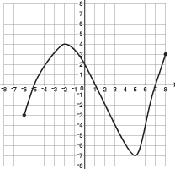
Domain | Range
x-intercept(s) | y-intercept
Absolute max: | Absolute min:
Relative max: | Relative min:
Increasing: | Decreasing:
Constant: | End behavior:
Function? | Continuous? Discrete?  Discontinuous?

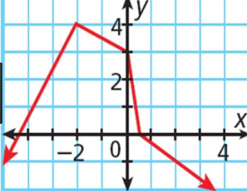
- f(0) = _______ b. f(1) = ________

- f(-2) = _______ d. f(2) = ________

- f(x) = 4, x = _______

- f(x) = 0, x = ____ & ______

- f(x) = 3, x = ____ & _______

- Tell if the following are functions or not. Explain how you know if it is or not? Use words here!
- 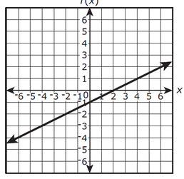 b. 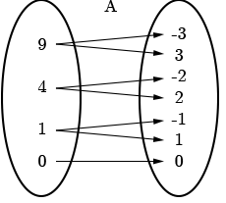 c. 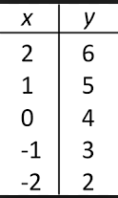 d.
Jenny is watching her credit card bill. Each month she pays $500 to it but then charges another $600 to it.

- The average salary of a garbage man (in thousands) from 1985 to 2001 is represented by the function
$f(x)=145x+192$ where x is the number of years since 1985.
- Find the value of f(5). Explain what the number means in terms of the problem.

- Find the value of x when f(x) = 1000. Explain what this means in terms of the problem.

- Find the value of f(10). Explain what the number means in terms of the problem.

- Find the value of x when f(x) = 1500. Explain what this means in terms of the problem.

- Given $f(x)=-10x-9 and j(x)=7x+4$ answer the following.
a. f(x) + j(x) | b. f(0) + j(2) | c. j(-3) – f(-3) | d. j(x) – f(x)

- Write out all the definitions for the following words.
  - Domain b. Range c. x-intercept d. y-intercept

- Absolute max f. Absolute min g. Relative max h. Relative min

- End behavior k. Constant m. Increasing n. Decreasing

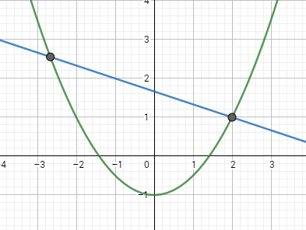
- Given the following graph, answer the following questions.
  - When is f(x) > g(x)?
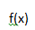

  - Where is f(x) = g(x)?

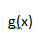
  - What is the value of f(2) + g(0)?

- Label the end behavior for the following graphs. Be sure you watch your negatives and positives.
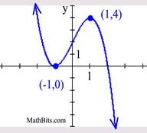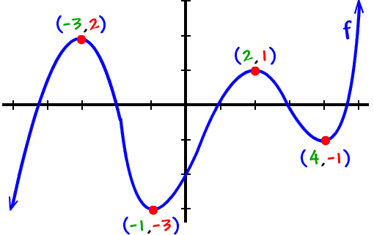
$$x→-∞, y→$$
$$x→∞, y→$$

$$x→-∞, y→$$
$$x→∞, y→$$

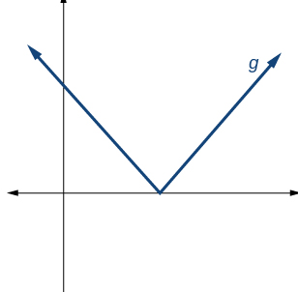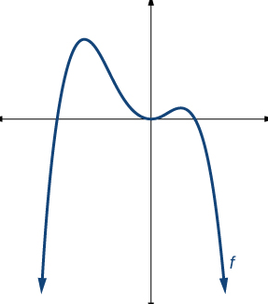
$$x→-∞, y→$$
$$x→∞, y→$$

$$x→-∞, y→$$
$$x→∞, y→$$

- How do you know if something is a function or not? What are the two main things that you need to test/know in order to prove something a function or not?

