Brandon has a budget of $75 to spend on clothes. The shirts he wants to buy are on sale for $10 each, and the pair of pants he wants costs $20 each. All prices include tax. Write an inequality to determine x, the maximum number of shirts, and y, the maximum number of pants Brandon can buy. | 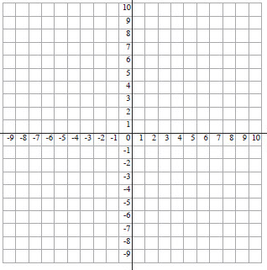  Don’t forget to shade | m =  b = | x represents  y represents | ____x + ____y < 75
On Wednesdays an athlete’s schedule allows for less than 75 minutes for morning training. One round of a strength routine, x, requires 10 minutes. One round of an endurance routine, y, requires 20 minutes. Which inequality could be used to determine the time available for the athlete to spend on strength and endurance routines on Wednesdays? | Don’t forget to shade | m = -1/2  b = 15/4 | x represents  y represents | 10x + 20y < 75
Anna makes hand-painted plates and cups. Her overhead costs are $75 per week, and she pays an additional $5 per cup in material costs. Anna sells the cups for $10 each. She pays an additional $10 per plate in material costs. Anna sells the plates for $25 each. Write an inequality to determine x, the minimum number of cups and y the minimum number of plates Anna has to sell each week before she can make a profit? | Don’t forget to shade | m =  b = | x represents  y represents | 75 < 5x + 15y
Best Buy is having a sale. If you buy more than $75 worth of CDs and DVDs, you can get a 25% discount off of your total price. If CDs are $10 each and DVDs are $25 each, write an inequality to describe the number of CDs, x, and DVDs, y, that he would have to buy to receive the discount. | Don’t forget to shade | m =  b = 3 | x represents  the number of CDs  y represents  the number of DVDs | 75 < x + y
Michelle sells cupcakes for $15 a dozen and specialty cakes for $35. Write an inequality to determine the number of dozens of cupcakes, x, and specialty cakes, y, she would have to sell in order to make at least $75? | Don’t forget to shade | m = -3/7  b = | x represents  y represents | 75 < 15x + 35y

