Module 0.1 Name: _______________________________
Relationships Between Quantities & Expressions

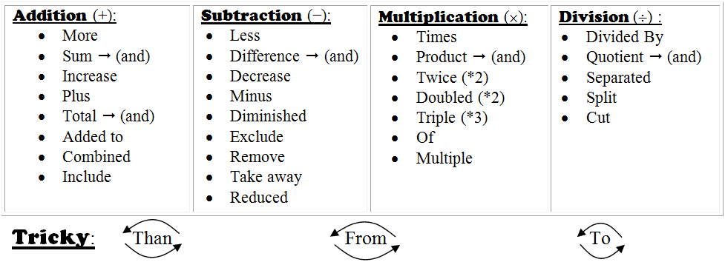
WORD WALL:

Convert the following phrases and sentences to algebraic expressions:

- “The sum of three and an unknown number.”

- “Three less than an unknown number.”

- “A number doubled reduced by five.”

- “The number of five increased by three
times a number.”

- “The product of three and an unknown
number diminished by eight.”

- “Four subtracted from a number.”

- “The quotient of a number tripled and six.”

- “Three times the sum of a number and four.”

- “Ten subtracted from twice a number.”

- “Twice the difference of 7 and a number.”

- 4 of a number increased by seven.

- Twice the total of a number and three.

- Five add to a number squared.

- Nine decreased by a number cubed.

- Lori is 4 years younger than Shawn. Write an expression that represents Lori’s age in relation to Shawn.

- Jennifer is 1 year older than twice Zack’s age. Write an expression that represents Jenifer’s age in relation to Zack.

- Jerry worked 2 hours less than four times as many hours as Katrina worked. Write an expression that represents the number of hours Jerry worked in relation to Katrina.

- In a given rectangle the shorter side is 2 units less than the longer side. If we let the longer side be represented as the variable x, create an expression that represents the perimeter of the rectangle.

- In an isosceles triangle (a triangle where two of the three sides called legs are equal), the legs are 1 unit less than twice the length of the base. If the length of the base of the triangle is represented by x, create an expression that represents the perimeter of the triangle.

- Andrea is three times older than Eliza. Suzie is 4 years older than Eliza. If Eliza’s age can be represented by x, create an expression that represents the combined age of all three girls.

M. Winking (Section 1-6)

p. 14

