Systems of Equations HW part 2 Name_______________________

1.) Decide whether (-2, -1) is a solution of the system of eqns. . (plug in for x and y on both eqns.)  6x - 3y = -15  2x + y = -3  2.) Decide whether (-3, -1) is a solution of the system of eqns.  (plug in for x and y on both eqns)  -x - 3y = 6  4x + y = -13  3.) Henry graphed the following system of equations:  x + y = 3  -2x + y = -6  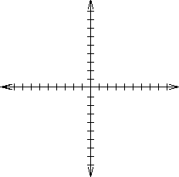  His guess is that the lines intersect at (2, 1). Is he right? | 4) What does the graph look like when there is:  a. one solution (draw it)  b. no solution (draw it)  c. infinitely many (draw it) | 5.) Which method is best to solve the following system? (do not solve, just tell what method)  -x - 3y = 6  y = -4x – 13  6.) Which method is best to solve the following system? Once you pick your method, solve it!  -x - 3y = 6  4x + y = -13  Word Problems  Set up and solve each of the following:  7.) In one day the Museum in TN collected $1590 from 321 people admitted to the museum. The price of adult ticket is $6 and the price of child ticket is $4. How many adults and how many children were admitted that day?

