GSE Algebra 1 HW #9.5 part 2 Name _________________________
Frequency Distribution Homework
1. Forty workers arriving at an office building in a city were asked how they got to work that day. They were also asked if they were less than 40 years old or older. The survey results are shown in the table.
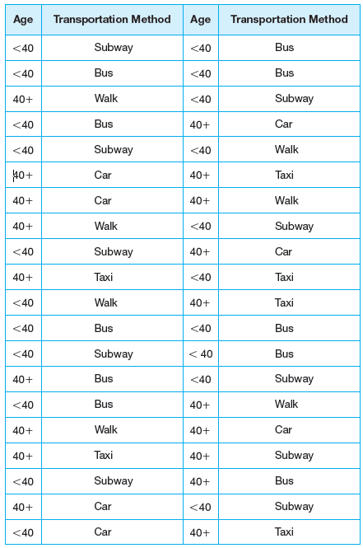
- Construct a frequency distribution for the survey data.

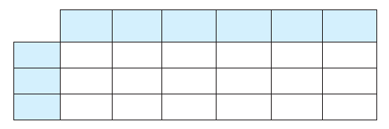

- What is the probability of an over 40 year old taking the bus to work?

- What is the percentage of people who rode the subway to work?

- What is the probability of an under 40 year old driving a car to work?

- How many under 40 year olds are there?

- How many over 40 year olds are there?

- How many over 40 year olds rode the bus to work?

- How many people under 40 year olds took a taxi to work?

a.) Fill in the table.
b.) What percentage of females takes the bus? c.) What percentage of bus riders are female?

d.) What percentage of kids takes the bus? e.) What percentage of kids that are female don’t take the bus?

f.) How many people rode the bus? g.) Give an example of a marginal, joint, and relative frequency.

h.) What percentage of males rode a bike? i.) How many people drive a car?

j.) What is the joint frequency of a female bike rider? k.) What percentage of people walk?

