GSE Algebra 1 HW #8.6 Name: ____________

Factor the following.
- $x^{2}+14x+49$ 2) ${2x}^{2}-40x$ 3) $x^{2}-49$

- ${2x}^{2}+13x-7$ 5) ${6x}^{2}+x-12$

Complete the square to solve for x.
- 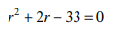 7)

- 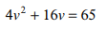 9) 