GSE Algebra 1 **HW #8.3** Name: _________________

Factor the following.

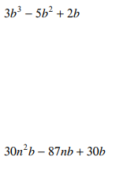 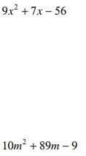 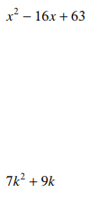

Solve the following by factoring. Be sure you get a 0 on one side before you start factoring!

(watch out for GCF’s)

