GSE Algebra 1 HW #7.8 Name ___________________________

1) $15,000 is deposited in an account that pays 3.5 % annual interest. Compare the amount in the account between a simple interest account and one that compounds with the specific number.
Simple Compound
t = 5 t = 5 compounded semi-annually

t = 10 t = 10 compounded quarterly

t = 15 t = 15 compounded monthly

2) You borrowed $59,000 for 6 years at 11% which was compounded semi-annually. What total will you pay back?

3) You have inherited land that was purchased for $30,000 in 1960. The value of the land increased by approximately 5% per year. What is the approximate value of the land in the year 2011?

4) Given: $A=900(1.53)^{t}$ 5) Given: $A=14(0.75)^{t}$
initial amount | Ratio | rate
initial amount | Ratio | rate

6) A new LED TV, purchases for $2500, loses 40% of its value a year. Develop a model to analyze the value of the TV over the course of 5 year and find the amount it is worth at year 5.

For the following, create the equations.
7) A linear graph that has vertically stretched by a factor of 5 and moved down 3 units.

8) A quadratic that has been reflected across the x-axis, vertically shrunk by a factor of ¼ and moved right 5 units.

9) An exponential decay that has an asymptote of -5 and moved left 7 units.

Graph the following equations. List out the transformations and the information needed to help you. (make tables if needed)
10) $y=\frac{1}{2}x+2$ 11) $y=-(x+3)^{2}-4$ 12) $y=2(\frac{1}{2})^{x}-2$

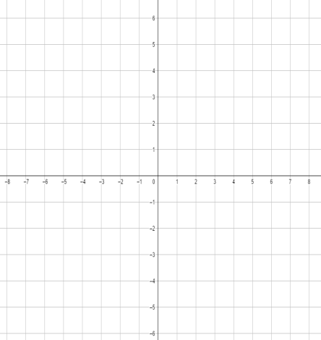
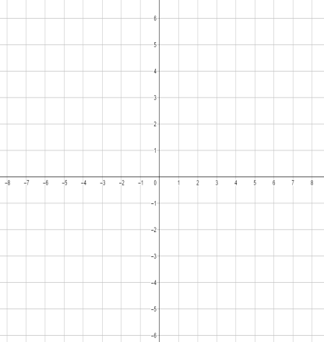

Moved? Moved? Moved?

y-int: Vertex: y-int:
x-int: Direction: Growth or decay?
Asymptote:

Evaluate.
13) $f\left(x\right)=3(3)^{x-3}+1 when x=3$ 14) $y=-4x^{2}-5x+3 when x= -1$

15) Given the following equation, tell what form it is in. Then follow the directions for each part.
$$y=(x-3)(x+3)$$
Form: x-ints: y-int: Direction:

Vertex:
- Add the two x-intercepts then divide by 2. Plug that number back in to get your k/y.

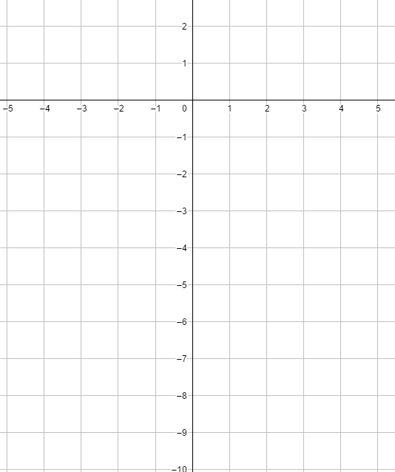

$$y=(x-3)(x+3)$$
Convert into standard form.

Convert into vertex form $x=-\frac{b}{2a}$ or use the vertex from
above and make the equation.

