GSE Algebra 1 HW #7.7 Name: ____________________

Write out the following equations given the scenarios.
- A quadratic that has been shifted right 4 units and down 8 units.

- A line that has been vertically stretched by a factor of 9 and moved up 3 units.

- A quadratic that has been reflected, moved left 3 units and up 9 units.

- A line that has been reflected and moved down 4 units.

- A quadratic that has been vertically stretched by a factor of 5 and moved up 9 units.

- An exponential growth that has been shifted 4 right and down 7.

- An exponential decay that has been reflected over the x-axis and left 3.

- An exponential growth has been reflected over the y-axis.

- An exponential decay that has been moved 4 right and up 5.

Graph the linear functions given and be sure to tell what has happened from the parent function y = x.
- $y=3x-3$ 11) $y=-\frac{1}{4}(x+2)$ 12) $y=\left(x-3\right)+2$
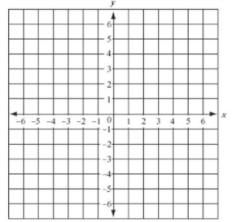
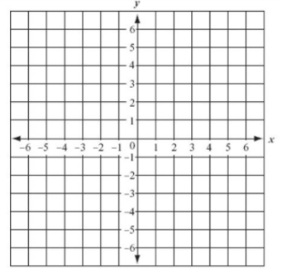
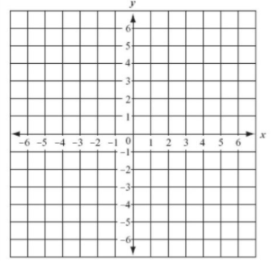

State whether they are maximums or minimums based off the equation.
- $y=2(x-1)^{2}+2$ 14) $y=-4x^{2}+1$ 15) $y=x^{2}-6x+1$

Find the vertex of the following. Then list out the axis of symmetry.
- $y=6x^{2}-12x+1$ 17) $y=-\frac{1}{4}x^{2}+4x-3$ 18) $y=x^{2}-5x$

- Which graph is wider? How do you know?
  - $y=\frac{1}{3}(x-1)^{2}+1$ b. $y=\frac{1}{10}x^{2}-9$

List out all the transformations that have happened from the parent function.
- $y=4(x-1)^{2}+3$ 21) $y=-(x+4)^{2}-4$ 22) $y=\frac{1}{5}x^{2}+10$

List out the transformations for the following exponentials. Be sure to label as growth or decay.
- $y=3({2)}^{x-3}+1$ 24) $y=-\frac{1}{2}({2)}^{x+4}-7$ 25) $y=-(\frac{1}{2})^{-x}-6$

Graph the following. Be sure to label the critical point and the asymptote.
- $y={\frac{1}{2}(4)}^{x}-4$ 27) $y=-3({\frac{1}{3})}^{x-3}$ 28) $y=2^{x+4}+2$

