GSE Algebra 1 HW #7.5 Name: _______________

Find the vertex and graph the parabola for the following equations.
- $f\left(x\right)=2x^{2}-12x+17$
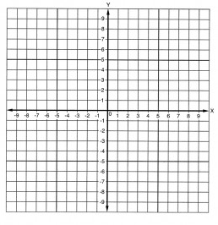

Vertex: Axis of Symm:

Direction: Make a table to graph

- $y=-(x-4)(x+6)$

Vertex: Axis of Symm:

Direction: Make a table to graph

- $f\left(x\right)=(x-4)^{2}-3$
Vertex: Axis of Symm:

Direction: Make a table to graph

Multiply out the following. Make a box or distribute whichever you prefer.
- $(4x-1)(x+3)$ 5) $-3(x-3)(2x+11)$ 6) $\frac{1}{2}(4x-8)(x-2)$

- Convert the following into vertex form: $y=4x^{2}-16x-1$

- Convert the following into standard form, then into vertex form: $y=\frac{1}{2}(2x-4)(x+1)$

Tell what the y-intercepts are for the following.
- $y=(x-1)(x+4)$ 10) $y=-8x^{2}-3$ 11) $f\left(x\right)=\frac{1}{2}(x-8)^{2}+2$

How has the graph moved/translated?
- $y=-\frac{1}{3}(x-3)^{2}-4$ 13) $f\left(x\right)=14(x+1)^{2}+45$

Substitute numbers in here
