GSE Algebra 1 HW #7.2 Name: ___________________

Multiply out the following to put in standard form.
- $y=(x-3)^{2}$ 2) $y=-(x+5)^{2}$

3) How could you move the graph of the quadratic in order for it to have two x intercepts? Up or down? Why?

Describe the transformations (where does the graph move)
4) $y=-10(x-1)^{2}-4$ 5) $y=\frac{1}{2}(x+2)^{2}+3$ 6) $y=-2x^{2}$

Graph the following. Then tell what the vertex is.
7) $y=4(x-1)^{2}+3$ 8) $y=-(x+3)^{2}$ 9) $y={\frac{1}{3}(x-4)}^{2}+4$
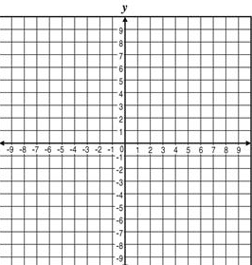

For the following table, list out all the information that you can.
