GSE Algebra 1 HW #7.1 Name: ____________

Make a dark point on the vertex. Then draw a dotted line on where the axis of symmetry would be. List out for each one what the vertex and the axis of symmetry would be.
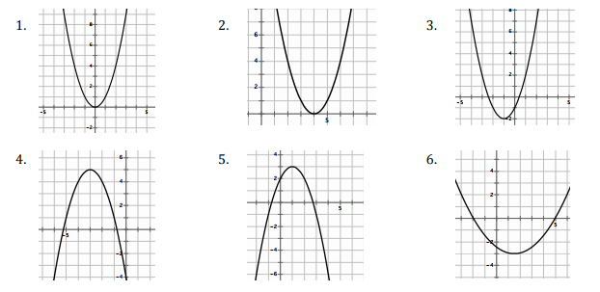

- What connection exists between the coordinates of the vertex and the axis of symmetry?

- How many x-intercepts can a parabola have? Draw a picture of what each one looks like on a graph.

- Draw a picture of a quadratic with no x-intercepts. What has to happen in order for a quadratic to have no x-intercepts? (think about where it needs to move)

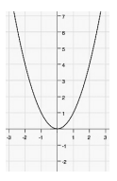
Given the following tables, graph the parabolas with the points given. Then tell how the graphs have moved from the original parent graph.

These two are the original that you compare the other graphs to.
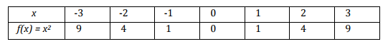

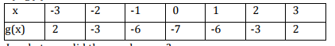

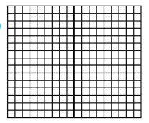

How has this graph moved from the parent graph?

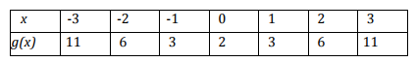

How has the graph moved from the parent graph?

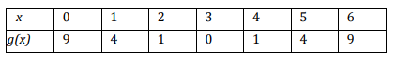

How has the graph moved from the parent graph?

Use your knowledge of shifts and tell where each of the following has moved.
- $y=4(x-1)^{2}+5$ 14) $y=-(x+3)^{2}$ 15) $y=\frac{1}{5}x^{2}-10$

