GSE Algebra 1 HW #6.6 Name: _______________

Evaluate the following.
- $f\left(x\right)=4x^{2}-4x+9 when x=9$ 2) $f\left(x\right)=-10x^{2}+3x-2 when x=-2$

- $f\left(x\right)=\frac{1}{2}x^{2}-10 when x=-1$ 4) $f\left(x\right)=-3x^{2}+4x when x=14$

List out all the characteristics for the following graphs bellow.
- 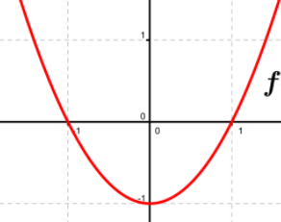
Dom: Range: max/min: x-ints:

Y-int: Vertex: A.O.S.: Incr:

Decr: Direc: Disc/Cont

End Beh: $x→-∞ y→$ $x→∞ y→$

- $y=-(x+2)(x-2)$
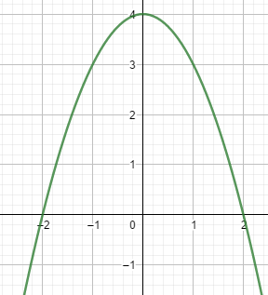
Dom: Range: max/min: x-ints:

Y-int: Vertex: A.O.S.: Incr:

Decr: Direc: Disc/Cont

End Beh: $x→-∞ y→$ $x→∞ y→$

Tell if the following are linear, exponential or quadratic. Be sure to tell why or draw a picture of what it is.
7) 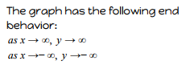 8) 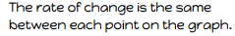

9) 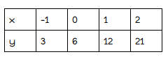 10) 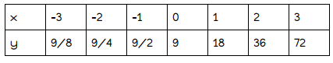

11) 12) 13) 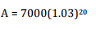

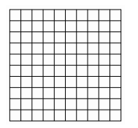
14) I had 81 freckles on my nose before I began using vanishing cream. After the first week I had 27 freckles, the second week I had 9, the third week I had 3.

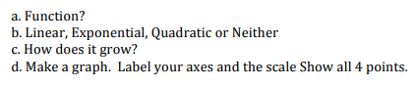

Multiply the following to put in standard form.
15) (4x – 1)(2x – 7) 16) -3(x – 1)(x + 5) 17) -10x(3x – 4)

18) Given the following characteristics, draw a picture on the graph of what it looks like.
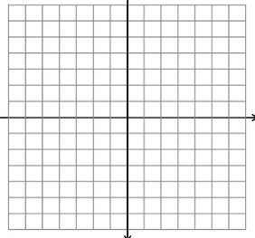
y-int : (0, -4) x-ints: (-5, 0) (5, 0) Range: [-4, oo)

