GSE Algebra 1 HW #6.5 Name: _______________________

Tell if the following are functions or not functions.
- 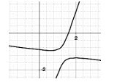2) 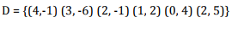 3) 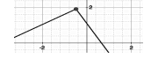

- How do you know if a function is NOT a function? Explain!

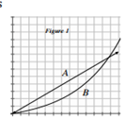
Compare the following rates of change.
The graph at the right shows a time vs. distance graph of two cars traveling in the same direction along the freeway.
- Which car has the cruise control on? How do you know this?

- Which car is accelerating? How do you know?

- Identify the interval in figure 1 where car A seems to be going faster than car B.

- For what interval in figure 1 does car B seem to be going faster than car A?

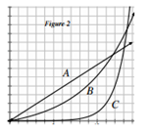
- A third car C is now shown in the graph (figure 2). All 3 cars have the same destination. If the destination is a distance of 12 units from the origin, which car do you predict will arrive first? Explain how you know!

- A positive quadratic, a positive linear and an exponential growth are all racing
to get to infinity. Who will get there first? Why?

- Tell the characteristics for the following functions.
Domain:
Range:
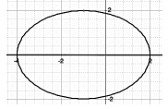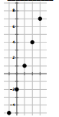
Domain:
Range:

- Tell all the characteristics for the following quadratic.
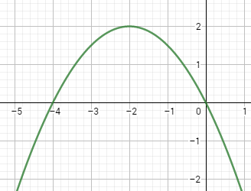
Domain: Range: x-ints:

y-int: Incr: Decr:

vertex: axis of symm: Direction:

function? Discr/Cont Max/Min:

End Beh: $x→-∞ y→$
$x→∞ y→$

- Given the following, put in standard form: $3(x-1)(2x+4)$

What are the x-intercepts for this quadratic? What direction will it face?

- Find the rate of change (SLOPE) for the following:
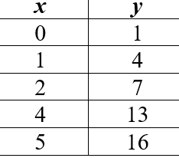
  - (2, 10) (-4, 6) b. Ramp: rises 10 ft, runs 50 ft c. From x = 1 to x = 5

