GSE Algebra 1 HW #6.3 – 6.4 Name: ___________________

Calculate the slope of the line between the given points. Use your answer to indicate which line is the steepest.
(Find the larger number and tell which one is steeper)

- A (-3, 7) B (-5, 17) 2) H (12, -37) K (4, -3)

Adam and his brother are responsible for feeing their horses. They have a porta fence that consists of 16 separate pieces of fencing that are each 10 feet long (so 16x10 = 160 feet). The brothers have ALWAYS arranged the fence in a long rectangular shape with one length of fence on each end and 7 pieces on each side, making the grazing area 700 feet. (DRAW THIS BELOW). In the chart, Adam lists all of the possible areas of a rectangle with a perimeter of 160 feet while keeping in mind that he is restricted by the lengths of his fencing units.
Fill out the chart below and answer each question to the best of your ability.

- Draw the picture of the fence below. (a rectangle)

Length in fencing units | Width in fencing units | Length in ft. | Width in ft. | Perimeter (ft) | Area (ft²)
1 unit | 7 units | 10 ft | 70 ft | 160 ft | 700 ft²
2 units |  |  |  | 160 ft
3 units |  |  |  | 160 ft
4 units |  |  |  | 160 ft
5 units |  |  |  | 160 ft
6 units |  |  |  | 160 ft
7 units |  |  |  | 160 ft

- Make a graph of Adam’s findings. Let the x axis be the length and the y axis be the area.
What shape does your graph make?

What kind of function is this?

What is the vertex?

So what does the vertex mean here?
Indicate which function on the graph has a higher rate of change (which one is increasing at a faster rate).
- 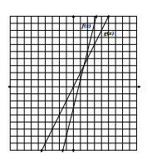 6) 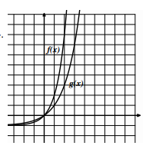

- For the following graph, which function has a higher rate of change over the interval from x = 0 to x = 2.5.
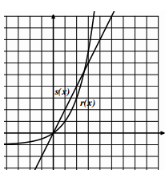
What happens after the two graphs intersect?

Which function takes over that has a higher rate of change?

- List out all the characteristics of the function and graph given below.
$y=(x+1)(x-5)$
Vertex: Dom: Range:

Direction: Max/Min y-int:

x-ints: Increase: Decrease:

axis of symm: End Beh: $x→-∞ y→$
$x→∞ y→$

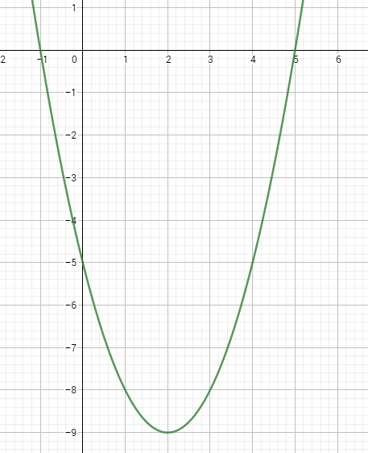
Write the equation above in standard form.
Solve the equation above for the x-intercepts.

