GSE Algebra 1 HW 6.2-6.3 Characteristics Name: ________________

- For the following, list out all that you know.
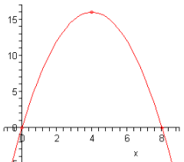
Vertex: Axis of symmetry: Function?

y-intercept: x-intercepts: Domain:

Direction: Max or min? Range:

Increasing: Decreasing: Disc/Cont

$$y=x(x+2)$$

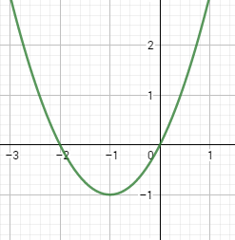
Vertex: Axis of symmetry: Function?

y-intercept: x-intercepts: Domain:

Direction: Max or min? Range:

Increasing: Decreasing: Disc/Cont

What do you notice about the equation and the graph?

Multiply out the equation to give you standard form.

- Multiply out the following binomials to put in standard form. ${ax}^{2}+bx+c$
- $(x+5)(x-7)$ b. (8x – 3)(2x – 1) c. (4x – 2)(8x + 10)

- –(x + 1)(x – 4) e. (3x – 5)(x – 1) f. –x(4x – 17)

- For the following tables, tell whether they are linear, quadratic or neither. Then show what the pattern is.
x | y
-3 | -23
-2 | -17
-1 | -11
0 | -5
1 | 1
2 | 7
3 | 13
x | y
-3 | 4
-2 | 0
-1 | -2
0 | -2
1 | 0
2 | 4
3 | 10
x | y
-3 | 48
-2 | 22
-1 | 0
0 | 1
1 | 4
2 | 9
3 | 16

- For the following pictures, tell what the Domain, Range, Vertex and Direction are.
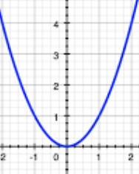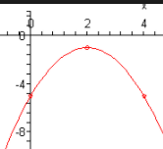
Domain:
Range:
Vertex:
Direction:
Domain:
Range:
Vertex:
Direction:

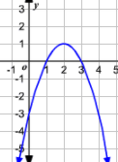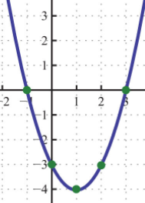
Domain:
Range:
Vertex:
Direction:
Domain:
Range:
Vertex:
Direction:

