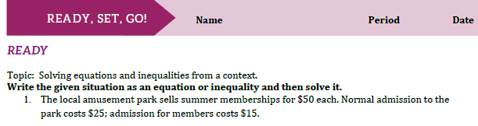
4.6
- If Darren wants to spend no more than $100 on trips to the amusement park this summer, how many visits can he make if he buys a membership with part of that money? | - How many visits can he make if he pays normal admission instead?
- If he increases his budget to $160, how many visits can he make as a member? | - How many can he make as a non-member with the increased budget of $160?
- Write an equation that can be used to calculate Jade’s score based on the number of questions she got right on the test. | - If a score of 70 points earns a grade of C-, how many questions would Jade need to get right to get at least a C- on the test?
- If a score of 83 points earns a grade of B, how many questions would Jade need to get right to get at least a B on the test? | - Suppose Jade got a score of 60% and then was allowed to retake the test. On the retake, she got all the questions right that she got right the first time, and also got half the questions right that she got wrong the first time. What percent of the questions did Jade get right, in total, on the retake?
