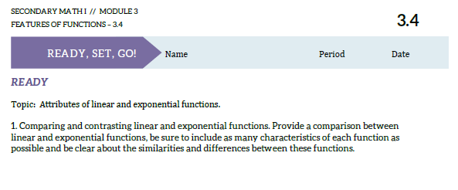

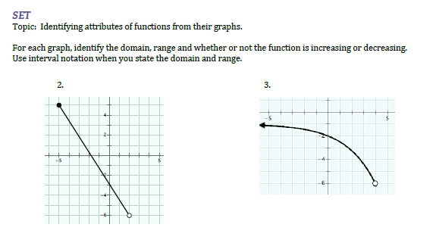

Domain: Domain:

Range: Range:

Increasing: Increasing:

Decreasing: Decreasing:

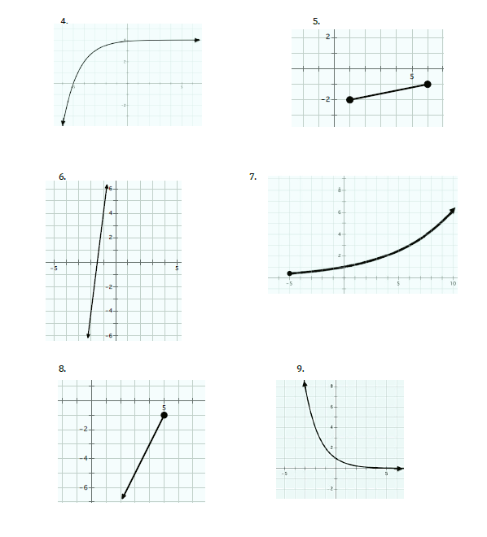

Domain:

Range:

Increasing:

Decreasing:

Domain:

Range:

Increasing:

Decreasing:

Domain:

Range:

Increasing:

Decreasing:

Domain:

Range:

Increasing:

Decreasing:

Domain:

Range:

Increasing:

Decreasing:

Domain:

Range:

Increasing:

Decreasing:

