GSE Algebra 1 Homework #3.2 Name: _______________

- Compare and contrast linear and exponential functions. List out at least 4 similarities and 4 differences between the two of them.

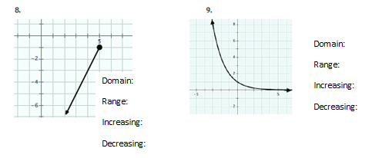
For the following graphs, list out the information asked below each graph.

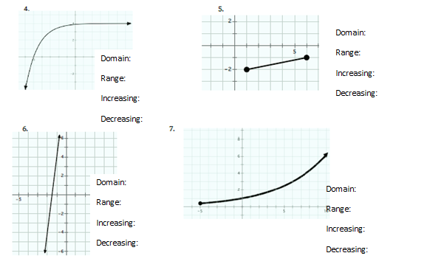
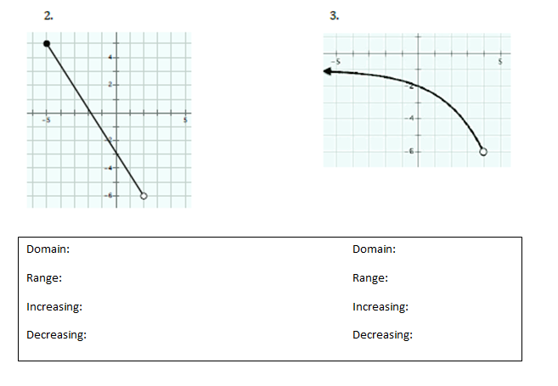
10. How can you tell when given a graph if the graph has no end behavior?

11. You are driving a remote control car around, racing your friend. Your car has an average pace of 70 feet per second. Your friends car has an average pace of 1000 miles per hour. Who is faster? Show how you got the answer.

12. When x is increasing and y is ________, the function is decreasing.

13. The product of an (irrational)(irrational) is always, sometimes or never irrational. (circle an answer)

14. What is the area of a play pen that you dropped your baby sister in that is $8x-3 wide and 2x+4 long?$
Mr. Multibank has developed a population growth model for the rockets in the field by his house. He believes that starting each spring the population can be modeled on the number of weeks with the function $p\left(t\right)=8({2)}^{t}$.
20) Find p(t) = 128 21) Find p(4) = 22) Find p(10)=

23) Find the number of weeks it will take the population to be over 20,000.

24) In a year with 16 weeks of summer, how many rodents would he expect by the end of the summer using Mr. Multibank’s model?

Fran collected data on the number of feet she could walk each second and wrote the following rule to model her walking rate d(t) = 4t.
25) What is Fran looking for is she writes d(12) = _______?

26) In this scenario, what does d(t) = 100 mean?

27) How can you write the function to indicate a time of 16 seconds walked?

28) How can the function be written to show that a distance of 200 feet was walked?
15. List out two ways that you can tell if a relationship is not a function.

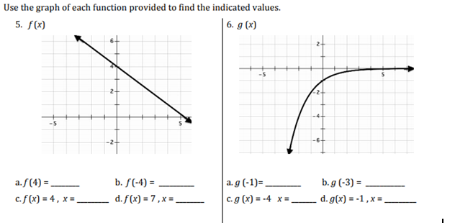
17.
16.

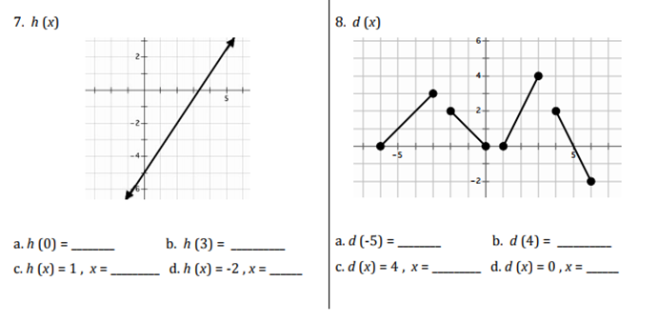
19.
18.

