GSE Algebra 1 Homework #2.6 Name:

Decide whether the word problem represents a linear or exponential function. Circle either linear or exponential. Then write the formula for the problem.
- A library has 8000 books and is adding 500 more books each year.
Linear or exponential? y = __________________

- There are 20,000 owls in the wild. Every decade, the number owls is halved.
Linear or exponential? y = ______________

- A bank account starts with $10. Every month, the amount of money in the account is tripled.
Linear or exponential? y = __________________

- At the start of the carnival, you have 50 ride tickets. Each time you ride the roller coaster, you have to pay 6 tickets.
Linear or exponential? y = ________________

Decide whether the table represents a linear or exponential function. Circle the correct word then create the formula.

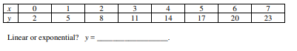

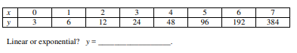

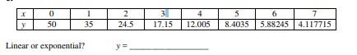

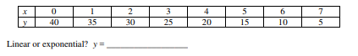

- Find the slope from the table provided:
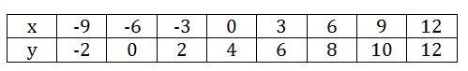 Sketch what the graph would look like.
A science experiment involves periodically measuring the number of mold cells present on a piece of bread. At the start of the experiment, there are 50 mold cells. Each time a periodic observation is made, the number of mold cells triples. For example, at observation #1, there are 150 mold cells.
- Write a function in function notation for the number of mold cells present.

- Fill in the missing outputs (range) of this table.
x = observation # | 0 | 1 | 2 | 3 | 4 | 5
y = mold cell count | 50 | 150

- Supposed the mold begins to be visible as green coloration when the mold cell count exceeds 100,000. On which observation will this happen?

- What will the mold cell count on the 20th observation be? When you find the answer on your calculator, it will be in scientific notation. Rewrite as the ordinary big number (move the decimal so you can see how big it is).

Label each equation as standard, slope-intercept or point slope. Then graph the equation on the graph provided.
- $y-8=3(x+1)$ 2) $y=-\frac{1}{3}x+4$ 3) $5x-10y=20$

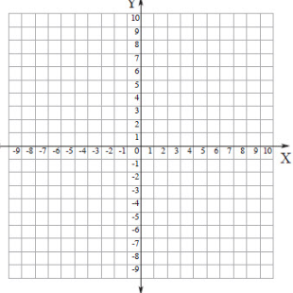

- Given the following, create the appropriate equation. Then list out all the information needed. Then graph.
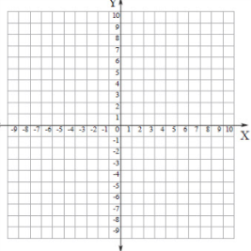
4) (10, 3) (-3, 4) find the slope - create the point slope equation – then convert to slope intercept – then graph.

5) 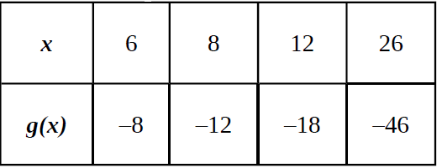 find the slope – create the point slope – convert to slope intercept – then graph.

6) The points (0, 5) and (4, 80) are plotted on a graph. What would be the exponential equation that matches these?

