Homework 2.3 Name:
You MUST show your work to receive full credit!
Decide whether the word problem represents a linear or exponential function. Circle either linear or exponential. Then write the formula for the problem.
A library has 8000 books and is adding 500 more books each year.  Linear or exponential?  y = __________________ | A bank account starts with $10. Every month, the amount of money in the account is tripled.  Linear or exponential?  y = __________________ | At the start of the carnival, you have 50 ride tickets. Each time you ride the roller coaster, you have to pay 6 tickets.  Linear or exponential?  y = __________________
Circle the situation which has the GREATER Rate of Change.
The amount of stretch in a short bungee cord stretches 6 inches when stretched by a 3 pound weight.  A slinky stretches 3 feet when stretched by a 1 pound weight. | y = 3x + 12 between (9, 2) & (-3, -8)  f(x)= -17x – 10  5
Pumping 25 gallons of gas into a truck in 3 minutes.  Filling a bathtub with 40 gallons of water in 5 minutes. | Riding a bike 10 miles in 1 hour.  Jogging 3 miles in 24 minutes.

A science experiment involves periodically measuring the number of mold cells present on a piece of bread. At the start of the experiment, there are 50 mold cells. Each time a periodic observation is made, the number of mold cells triples. For example, at observation #1, there are 150 mold cells.
- Fill in the missing outputs (range) of this table.
x = observation # | 0 | 1 | 2 | 3 | 4 | 5
y = mold cell count | 50 | 150

- Write a function in function notation for the number of mold cells present.

- Supposed the mold begins to be visible as green coloration when the mold cell count exceeds 100,000. On which observation will this happen?

- What will the mold cell count on the 20th observation be? When you find the answer on your calculator, it will be in scientific notation. Rewrite as the ordinary big number (move the decimal so you can see how big it is).

Label each equation as standard, slope-intercept or point slope. Then graph the equation on the graph provided.
$$y-8=3(x+1)$$  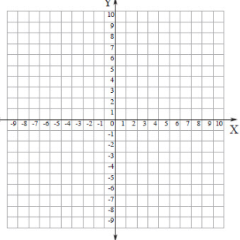 | $$y=-\frac{1}{3}x+4$$ | $$5x-10y=20$$

Find the slope between (10, 3) &(-3, 4) | Use the info from the left to write the equation of the line in Point-Slope form, then convert to Slope Intercept Form | Graph the linear function to the left on the graph below.
Find the slope:  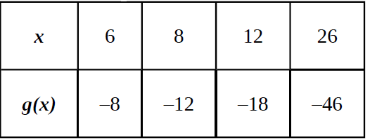 | Use the info from the left to write the equation of the line in Point-Slope form, then convert to Slope Intercept Form | Graph the linear function to the left on the graph below.
Solve for the variable.  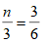 | Solve for the variable.  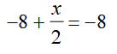 | Solve for the variable.  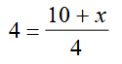
Put in Slope Intercept Form:  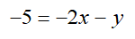 | Given an exponential growth and a positive linear graph, which one will grow faster over time? | Convert 4500 fluid ounces into quarts.
What is the y-intercept for the following equation: 3x – 4y = 12 | Solve the following equation for x: -3x – 45 = 30 | Does the product of a rational*rational never, sometimes or always produce an irrational?

