GSE Algebra 1 HW #1.9/1.10 Name:

See if you can fill out the necessary information for the tables below. Be sure to show all your work!

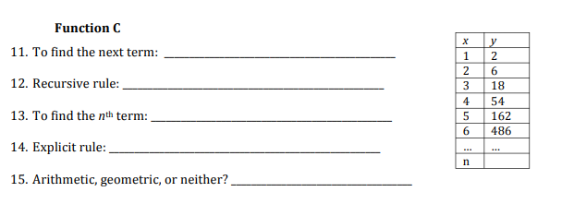
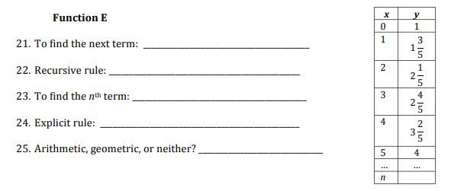
11) For the following, you are given a specific section of a problem. Fill in all the empty parts that you need.
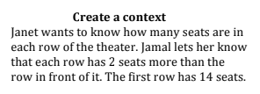
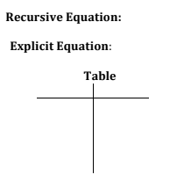
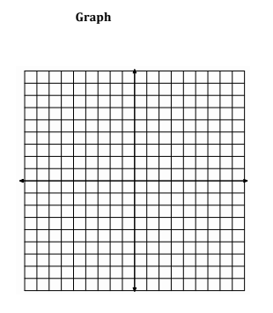

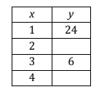
12) For the following arithmetic sequences, find the missing terms.
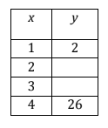

13) Given the recursive function for the following arithmetic sequence, create the explicit.
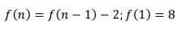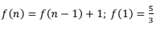

14) For the following, you are given a specific section of a problem. Fill in all the empty parts that you need.
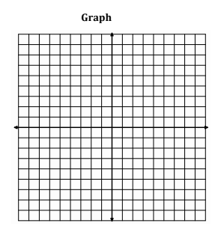
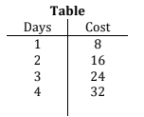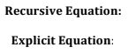

15) Fill in the missing terms for the followin geometric sequences. Then create the explicit equation.
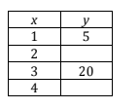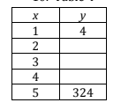

16) For the following, fill in the chart according to the right sequence. Then answer the following questions.
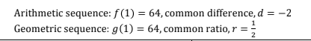
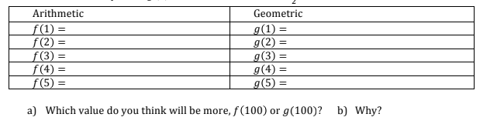

b) Create the recursive and explicit for each sequence above.

