GSE Algebra 1 HW #1.5 Name:

Ready
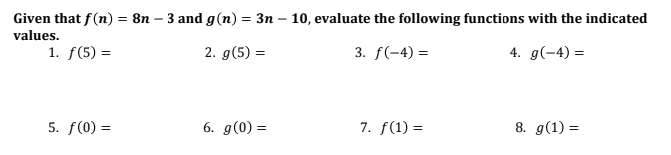

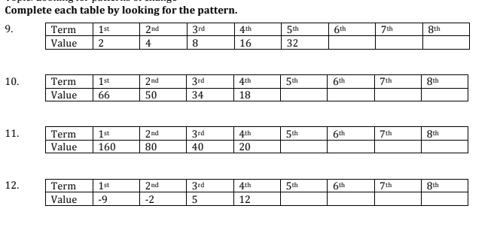

Set
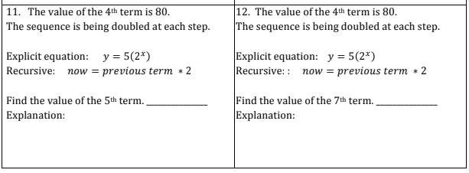
13.
14.
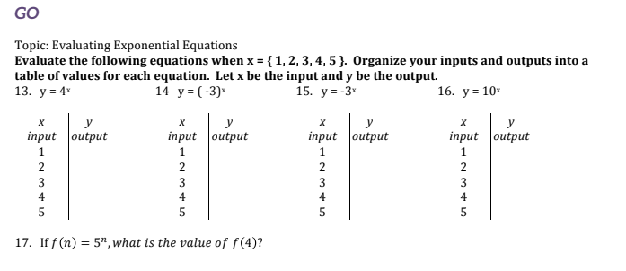
16.
17.
18.
19.
15.

For the following, find the difference. Then find the 1st term. Then find the appropriate equation asked. All of these below are ARITHMETIC!

20. $a_{13}=11 a_{31}=83$ 21. $a_{17}=-112 a_{32}=-247$
Create the explicit once you find everything. Create the recursive once you find everything.

Write the following in function notation.
22. $a_{n}=5n-10$ 23. $45, 51, 57, 63…$

