GSE Algebra 1 HW #1.4 Name:

Ready
Find the missing values for the following arithmetic sequence. Tell the common difference. Then come up with the explicit and recursive formulas for each.
- 5, 10, 15, ______, 25, 30, _____... 2) 30, 24, _____, 12, 6, ____...

- $\frac{1}{3},1,\frac{5}{3},___,3,____…$ 4) $-120, ____,-96,____…$

For each scenario or table, find the common difference. Then find the 0 term. From there, find the explicit and recursive formulas.

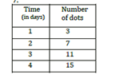
Michelle likes chocolate but it causes acne. She chooses to limit herself to three chocolate bars every 5 days. (So, she eats part of a bar each day).
- 6)

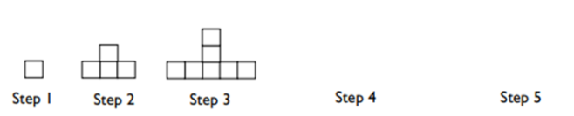
- Vanessa has $60 to spend on rides at the state fair. 8)
Each ride costs $4.

Set
Evaluate the following.
- $f\left(n\right)=3+4\left(n-1\right) Find f\left(5\right) and f(0)$

- $f\left(n\right)=2\left(n-1\right)+6 Find f\left(1\right) and f(6)$

Two consecutive terms in an arithmetic sequence are given. Find the recursive function.
- $If f\left(3\right)=5 and f\left(4\right)=8…$
$f\left(5\right)=_______f(6)=____________$ Recursive function: _____________

- $If f\left(2\right)=20 and f\left(3\right)=12…$
$f\left(4\right)=_________f(5)=________$ Recursive function: _____________

- $If f\left(5\right)=3.7 and f\left(6\right)=8.7…$
$f\left(7\right)=_______f(8)=________$ Recursive function: _____________

GO
For the following problems, two points are given. Plot and label these two points on the graph. Then find the slope (common difference).
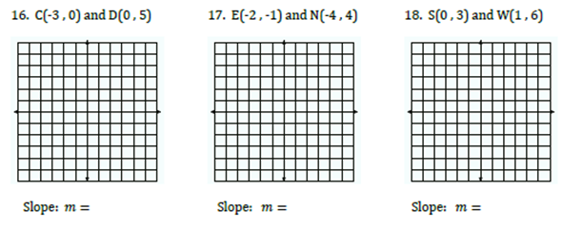
15)
16)
14)

Given the following terms, find the first term and then the explicit formula. Then create the recursive formula.
- $a_{12}=35 a_{39}=89$ 18) $a_{10}=-87 a_{37}=-357$

Given the recursive formula, create the explicit. Given the explicit formula, create the recursive.
- $a_{1}=10 a_{n}=a_{n-1}-3$ 20) $a_{n}=6+\frac{1}{2}n$

