Homework 1.1 Name:
You MUST show your work to receive full credit!
Write the following algebraically:  Two less than a number squared | Simplify the following:  $$\left(3x-7\right)-\left({2x}^{2}+8x-10\right)$$ | Simplify the following:  $$\left(2x-4\right)\left(5x-6\right)$$
Simplify the following:  $$-3\sqrt{224x^{3}y^{7}}$$ | Simplify the following:  $$3\sqrt{2}\left(2\sqrt{24}- \sqrt{40}\right)$$ | Convert 936 inches per hour to feet per minute
Find y when x = 8 for the following:  $$y=6x-15$$ | Find y when x = -5 for the following:  $$y= -4x+9$$ | Find x when y = 13 for the following:  $$y=2x-1$$
Write the arithmetic sequence (explicit) for the following:  x 1 2 3 4  y 485 470 455 440 | Write the arithmetic sequence (explicit) for the following:  x 1 2 3 4  y 10 20 30 40 | Write the arithmetic sequence (explicit) for the following:  x 1 2 3 4  y 37 49 61 73
Create the recursive formula for the following arithmetic sequence:  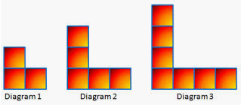 | Create the explicit formula for the following arithmetic sequence: | Find the 52nd term for the following:
The value of the 8th term is 78. The sequence is increasing by 10 at each step. Write the explicit equation. | The value of the 8th term is 78. The sequence is increasing by 10 at each step. Find the 20th term. | The value of the 8th term is 78. The sequence is increasing by 10 at each step. Find the 9th term.
Fill in the blanks:  - 3, 8, 13, 18, ____, ____, ____..  - Common Difference: ____  - Recursive Formula:  - Explicit Formula: | Fill in the blanks:  - 11, 9, 7, 5, ____, ____, ____..  - Common Difference: ____  - Recursive Formula:  - Explicit Formula: | Fill in the blanks:  - 3, 1.5, 0, ____, ____,____...  - Common Difference: ____  - Recursive Formula:  - Explicit Formula:
Explicit equation: $a_{n}=3n+7$  Recursive: $a_{n}=a_{n-1}+3$  Term# 1 2 3 4  Value 10 13 16  Find the 4th term: _____  Which formula did you use and why? | Explicit equation: $a_{n}=3n+7$  Recursive: $a_{n}=a_{n-1}+3$  Term# 1 2 … 52  Value 10 13 …  Find the 52nd term: _____  Which formula did you use and why? | What is the common difference for the following:  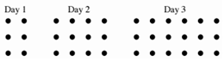
Write the recursive formula for the following: | Write the explicit formula for the following: | Create a graph for the picture to the left.  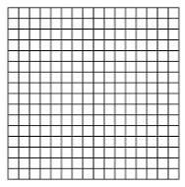
I have a common difference of -3 and my first term is 28. Write my explicit formula: | My first term is 7. My 6th term is 32. What is my common difference?  Write my explicit formula: | My first term is 72. My 8th term is 24. What is my common difference?  Write my recursive formula:

