Honors Homework 2.1 Name:
You MUST show your work to receive full credit!
Convert 1000KL per day into gallons per hour. (3.79 L = 1 gal) | The perimeter of a rectangle is $24x-5$ . The length is $3x-6$. Find the width | Provide an example of when the product of two irrational numbers is rational.
Simplify:  $$3x\left({-4x}^{3}-10x^{2}-5x\right)+x^{3}$$ | A rectangle has a length of x² +1 and a width of 2x+7. What is the area of the rectangle? | Which one has a greater rate of change?  - $y={2(5)}^{x}$  - In the children’s book, The Magic Pot, every time you put one object into the pot, two of the same objects come out. Imagine that you have 5 magic pots.
Determine if the sequence is arithmetic, geometric or neither. Then list out the next 4 terms.  3, 5, 8, 12… | Determine if the sequence is arithmetic, geometric or neither. List out the next 4 terms and create the explicit equation.  4, -20, 100, -500… | Given the 7th and 11th term of an arithmetic sequence. Create the explicit formula.  A(7)= $\frac{14}{3}$ a(11)= $\frac{10}{3}$  Explicit:
Given that the 10th term of a sequence is 22 and the common difference is 6, find the 5th term. Create the explicit equation that goes with this. | Find the rate of change (slope) for the table below.  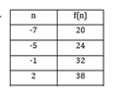 | Given the explicit formula below, write the recursive. Then list out the first 3 terms  a (n)= -12 + 4n  Recursive:
Create a graph that matches an arithmetic sequence and a graph that matches a geometric sequence. Be sure to label them.  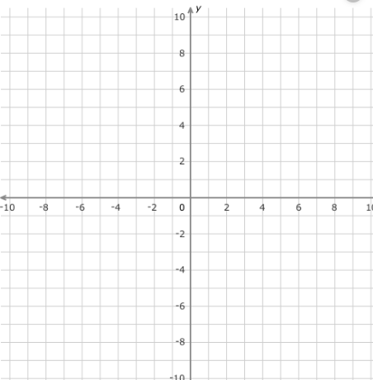 | Determine if the sequence is arithmetic, geometric or neither. List out the next 4 terms. Then create the recursive equation.  -64, -47, -30, -13… | Write the explicit formula for the sequence below and then find the 70th term.  -3, -7, -11  Explicit:  A(70)=
State which one has a greater rate of change:  - A sunflower grows 2 inches everyday  - An amaryllis that grows 18 inches in a week | Write explicit formula and then find which term will have a value of 54  6, 9, 12, 15  Explicit  A(___)= 54 | Given the explicit formula below write the recursive. List out the first 5 terms.  $$a_{n}=-6({2)}^{n}$$
In a geometric sequence, a(15)= 2,560 and r=2. Find a(1). Make the explicit formula. | Best Buy Shoes had a back to school special. The total bill for six pairs of shoes came to $69.24 (before tax). How much did the average price of shoes cost? | Solve: $\frac{1}{4}x=2$
Tell if the following are discrete or continuous, linear or exponential.  - For every hour that passes the amount of bacteria doubles.  - The water flowing down the Mississippi River at a rate of 4 ml/sec. | In a geometric sequence, a(6)=36 and a(12)= 2304. Find the constant ratio then write the recursive formula | Solve the following:  2x – 6 = -12
Given the following two terms of an arithmetic sequence, write the explicit formula.  A(5) = 45 a(23)= -9  Explicit: | In an arithmetic sequence the 10th term is 450 and the common difference is 5. Find the 51st term. | Write the explicit formula for a geometric sequence where the second term is 10,000 and the 5th term is 80.
Tell if the following is discrete or continuous, linear or exponential:  - To meet the demands placed on them the brick layers have started to increase the number of bricks they lay by 5% each day.  - The number of students who are late on a bus increases by 4. | Explain why the following table has more than one answer for its missing terms. Then state what those two possible answers are for each term.  X 1 2 3 4 5  y -10 -40 -160 | What is one main difference between discrete data vs. continuous data?

