Helpful hints on Discrete vs. Continuous!
 | Discrete | Continuous
Tables | n f(n)  1 2  2 3  3 4  4 5 | x f(x)  0 1  0.25 1.25  0.5 1.5  0.75 1.75
Graphs | 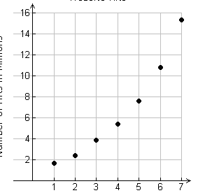 | 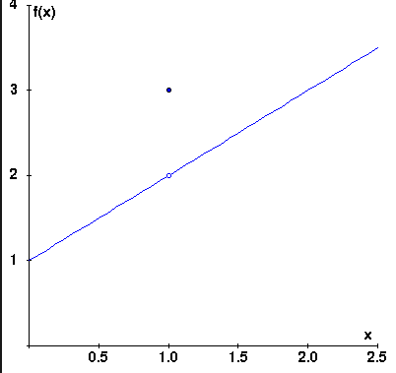
Equations | Recursive: $a_{1}=2, a_{n}=a_{n-1}+1$  Explicit: $a_{n}=n+1$ | $$f\left(x\right)=x+1$$
Context | Change happens ALL AT ONCE | Change happens continuously
Domain: | $$whole numbers$$  $$natural numbers$$  $$\left\{n\left|n is a whole number\right.\right\}$$  $$\left\{n\left|n is a natural number\right.\right\}$$ | $$real number$$  Can include decimals  Option: could be only positive numbers (such as time)  $$\left\{x\left|x\right. is a real number\right\}$$

