Compare and Contrast
Linear, Exponential and Quadratic Functions

How are the functions below similar or different?

Attribute | Linear  $$f\left(x\right)=2x+3$$ | Quadratic  $$f\left(x\right)=2x^{2}+3$$ | Exponential  $$f\left(x\right)=2^{x}+3$$
Rate of change
Domain & Range
Intercepts
Asymptotes |  |  | 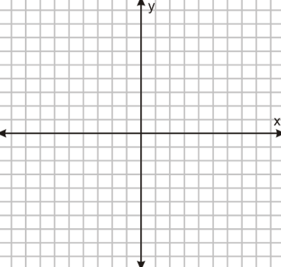
End Behavior

