GSE Algebra 1 Midterm Review Fall 2018 Name: _____________

**The midterm is all multiple choice. If you can complete this review, then you should be good on the test.**

1. Haley runs at an average of 7 miles per hour. What is her speed in feet per minute? (1 mile = 5280 feet)
2. Find the product. (3r + 2)(4r - 5) 3. Simplify without a calculator: -4 $\sqrt{45}$
3. Use the expression 2x4 + 3x3 - 2xy + 14 to answer the following:
   1. It has ______ terms
   2. The highest degree is _____
   3. The coefficient of the xy term is _____
   4. 14 is called a _____________________.
4. Simplify the expression. (6a3 + 7) + (4a + 6a2 – 3) - (a2 - 2a4)
5. The initial cost to play a game of ping pong at the rec center is $3.00. There is a $5.00 fee for every hour we play. Write an equation to represent this situation.
6. Justify each step in the solution below.

* Given*

* ___________________________*

* ___________________________*

* ___________________________*

* ___________________________*

1. Which of the following can be further simplified? Why is it possible?

$\sqrt{3}+ 3\sqrt{2}$

$6\sqrt{3}- 3\sqrt{7}$

$\sqrt{7}+ 3\sqrt{7}$

$\sqrt{7}+ \sqrt{11}$

1. The width of a rectangle is represented by 3x and the length is represented by x -2. Give the following in terms of x:
   1. Perimeter b. Area
2. If the length of each side of a square is represented by x - 5, write the expression that represents the perimeter?
3. Rational & Irrational
   1. The product of two rational numbers is ____________ rational . (Always, sometimes, never)
   2. The sum of two rational is ___________ rational. (Always, sometimes, never)
   3. The product of a rational and an irrational number is __________ rational. (Always, sometimes, never)
   4. The sum of two irrational numbers is ____________ irrational. (Always, sometimes, never)
4. In the equation 3x - 4y = 24, what is the **x-intercept** and **y-intercept**?
5. If $g\left(x\right)={3x}^{2}+2x-3$, what is the value of g(-4)?



1. Are the following functions? Why or why not?
   1.  b.
2. Each week, Tim wants to increase the number of miles he does daily by ½ mile. The first week, he runs 3 miles each day. Write the explicit function to represent the number of miles, f(n), he runs daily in week n.

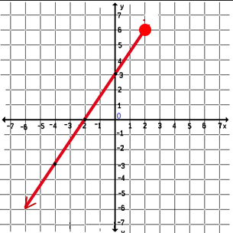**Use the graph to answer the following:**

1. What is the domain?

**Interval: Inequality:**

1. What is the range?

**Interval: Inequality:**

1. What is f(-2)= ?
2. For what value is f(x) = -3?
3. Circle the graphs that do not represent a function?

|  |  |  |  |
| --- | --- | --- | --- |
| A. |  | C. |  |
| B. |  | D. |  |

1. A wheelchair ramp runs 24 inches and rises 2 inches. What is the slope (rate of change) of the ramp?
2. 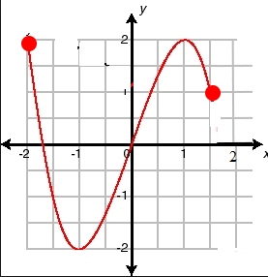A scientist drew the following graph to show the changes in the temperature during a 2-hour period. What are the domain and range of this data set?

**Domain: Interval: Inequality:**

**Range: Interval: Inequality:**

1. 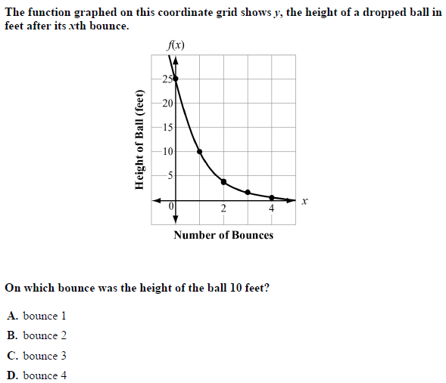The function graphed on this coordinate grid shows y, the height of a dropped ball in feet after its *x*th bounce. On which bounce was the height of the ball 4 feet?
2. Draw a picture of the following:
   1. Pos. slope linear b. Neg. slope linear c. Exponential growth d. Exponential decay

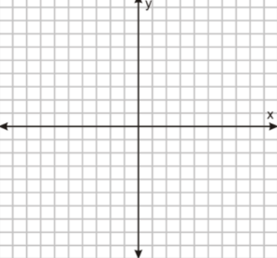

1. Solve for y: 2(x + 4) = 2(y + 3)
2. Identify the intervals of increase for the following graph.

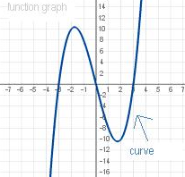

1. What is the slope of the line that passes through the points (-5, -3) and (7,- 5)?
2. If f (x) = 3x – 5 and the domain of f is {1, 3, 5}, what is the range of f (x)?
3. Given the graph of f(x) to the right, what is f (3)?
4. Write the **recursive** function for the following sequence: 13, 26, 52, 104, …
5. The first term in this sequence is 3. What is the 15th term?

|  |  |  |  |  |  |  |
| --- | --- | --- | --- | --- | --- | --- |
| n | 1 | 2 | 3 | 4 | 5 | … |
| an | 3 | 10 | 17 | 24 | 31 | … |

1. The first term in this sequence is -1. Write the **recursive** and **explicit** function of the sequence.

|  |  |  |  |  |  |  |
| --- | --- | --- | --- | --- | --- | --- |
| n | 1 | 2 | 3 | 4 | 5 | ….. |
| an | -1 | 1 | 3 | 5 | 7 | ….. |

**Recursive:**

**Explicit:**

1. A population of bacteria has an average growth rate of 3% per hour. If there were 100 bacteria originally, approximately how many would there be after 150 hours?
2. Create the equation for the graph below:

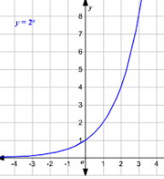

1. Write the **recursive** and **explicit** function that represents the sequence for the pattern below:

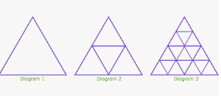

Use the graph to answer 36-38:

36. Write the equation for the line:

37. What is the y-intercept of the line?

38. What is the x-intercept of the line?

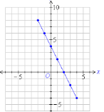

1. If $f\left(x\right)= -3x+7$ and $g\left(x\right)= {2x}^{2}-3$, what is the value of $f\left(6\right)+g(4)$:
2. Makayla and her friends decided to go see Elf the Musical. Makayla paid $5 for each friend to get into the show and then spent $12 on concessions. Write a linear equation that represents this situation.
3. What is the missing justification?

Given

Distributive Property

Combine Like Terms

____________________________

Division Property of Equality

$$2\left(x+3\right)-5x=24$$

$$2x+6-5x=24$$

$$6-3x=24$$

$$-3x=18$$

$$x= -6$$

1. Put the following in slope-intercept form:
$$-4x-6y ≤24+2x$$

2. What is the inequality for the following number line:

-7

1. Solve the following and then graph it on the number line:

$2\left(x-3\right)-4x ≥16$

1. Solve the following equation for **x**: $xy-ab=c$