Correlation

- A scatter plot has a correlation of r = -0.95. What does that tell you about the scatter plot?

- Draw a scatter plot that could have a correlation of r = -0.95.

Label each scatter plot as positive linear, negative linear, positive quadratic, negative quadratic, positive exponential, negative exponential or none. Be sure that you tell why!
- 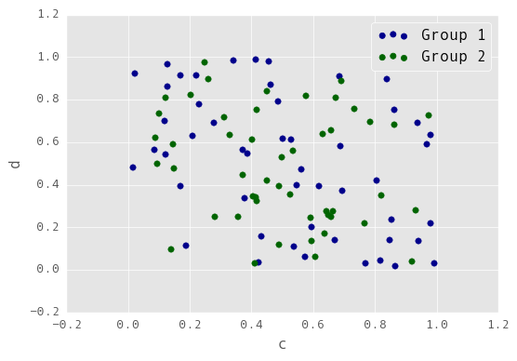 b. 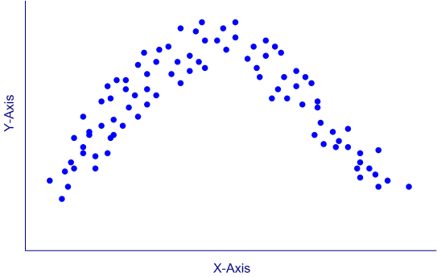 c. 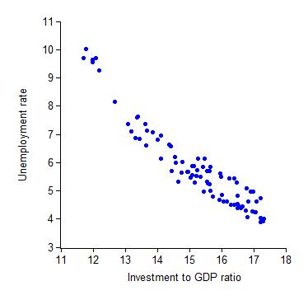

- 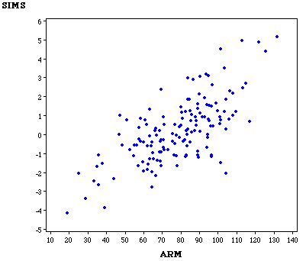 e. 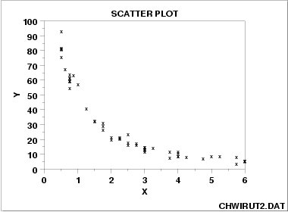 f. 

 