GSE Algebra 1 **8.8 – The Quadratic Formula** **Notes**

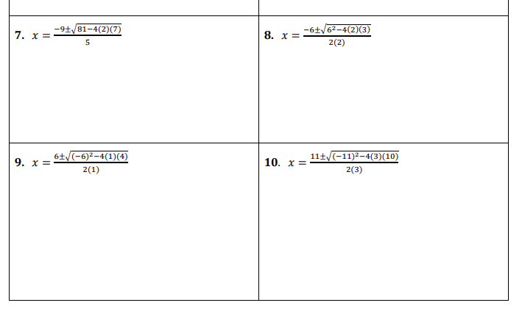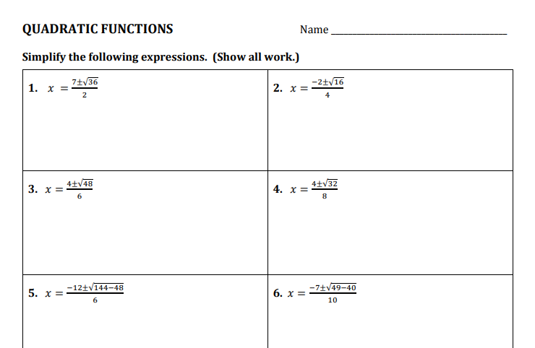

|  |
| --- |
| Quadratic Formula $x=\frac{-b±\sqrt{b^{2}-4ac}}{2a}$ |

Equation: ${2x}^{2}-5x+2=0$***a*** = _____ ***b*** = _____ ***c*** =

$$x = \frac{-( )±\sqrt{{( )}^{2}-4( )( )}}{2( )}$$



$$=\frac{ ± \sqrt{ - }}{}$$



$=\frac{ ± \sqrt{ }}{}=\frac{ ± }{}=\frac{}{} \& \frac{}{}$

 _____

**Practice**

**Quadratic Formula**

Name: ________________________________________ Date: _______________



**Directions:**

* Solve each equation using the quadratic formula, write out the formula for each problem.
* Be sure to show all steps and substitution.

|  |  |
| --- | --- |
| 1.) $4x^{2}+11x-20=0$ a = ______  b = ______  c = ______        *x* = { } | 2.) $x^{2}-5x-24=0$ a = ______  b = ______  c = ______ |
| 3.) $x^{2}=3x+3$ a = ______  b = ______  c = ______ | 4.) $x^{2}+5=-5x$ a = ______  b = ______  c = ______ |
| 5.) $x^{2}=-x+1$ a = ______  b = ______  c = ______ | 6.) ${4x}^{2}-1=-8x$ a = ______  b = ______  c = ______ |

GSE Algebra 1 **HW #8.8**  Name: ____________

Use the quadratic formula to solve for all the following. $x=\frac{-b±\sqrt{b^{2}-4ac}}{2a}$

1. $x^{2}+9x+20=0$ 2) $x^{2}-5x-24=0$
2. $x^{2}=3x+3$ 4) $x^{2}+5=-5x$
3. $x^{2}=-x+1$ 6) ${4x}^{2}-1=-8x$
4. ${4x}^{2}+7x-15=0$ 8) $x^{2}+3x-10=0$