GSE Algebra 1 7.7 – Exponential shifts Name: _________________

Exponentials have two graphs, GROWTH 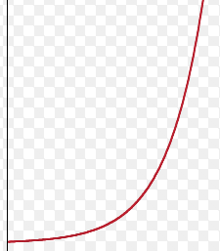and DECAY.

ALL OF THESE GRAPHS START AT (0, 1)!
GROWTH  $$y=2^{x}$$  PARENT GRAPH  Asymptote: y-int:  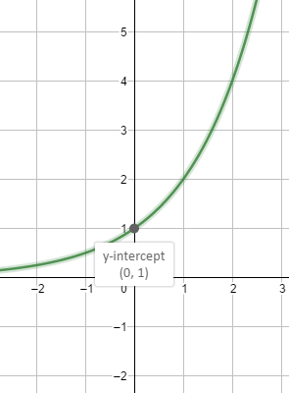 | $$y=2^{x}+3$$  How do we move?  Asymptote: y-int:  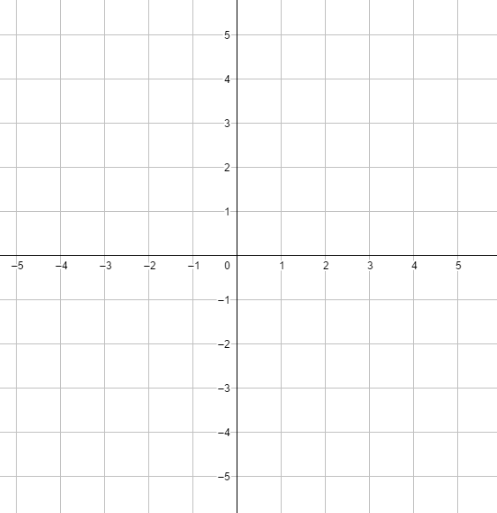
$$y=2^{(x-3)}$$  How do we move?  Asymptote: y-int: | $$y={-1(2)}^{x}$$  How do we move?  Asymptote: y-int:
$$y=4{(2)}^{x}$$  How do we move?  Asymptote: y-int: | $$y={\frac{1}{2}(2)}^{x}$$  How do we move?  Asymptote: y-int:
$$y=2^{(x+2)}-2$$  How do we move?  Asymptote: y-int: | $$y={3(2)}^{x}-4$$  How do we move?  Asymptote: y-int:
DECAY  $$y={\frac{1}{2}}^{x}-4$$  How do we move?  Asymptote: y-int: | $$y={\frac{1}{2}}^{(x+3)}$$  How do we move?  Asymptote: y-int:
$$y=2({\frac{1}{2})}^{x}-2$$  How do we move?  Asymptote: y-int: | $$y=-({\frac{1}{2})}^{x}$$  How do we move?  Asymptote: y-int:

- When you are in the exponent, you move _________ or _________ (think opposite)

- When you are in the back of the equation (_____________) you move _____ or _________

- BIG DIFFERENCE BETWEEN GROWTH AND DECAY IS
Write the equations for the following specific scenarios.
- An exponential growth that has been shifted right 5 units and down 3 units.

- A quadratic that has been reflected over the x-axis and left 3 units.

- An exponential decay that has been vertically stretch by a factor of 10.

- An exponential growth that has an asymptote of 4 and moved right 2 units.

- A quadratic that has been horizontally stretched by ¼ and moved down 6 units.

- A line that has a slope of 10 and a y-intercept of 2.

- An exponential decay that has been vertically shrunk by a factor of 1/6 and reflected over the x-axis.

- An exponential growth that has been moved left 8 units and has an asymptote of -4.

