GSE Algebra 1 7.6 – linear shifts Name: _________________

A line is going to shift very similar to a quadratic.

Let’s look at what we have.

$$y=x$$  PARENT GRAPH  x-int: y-int:  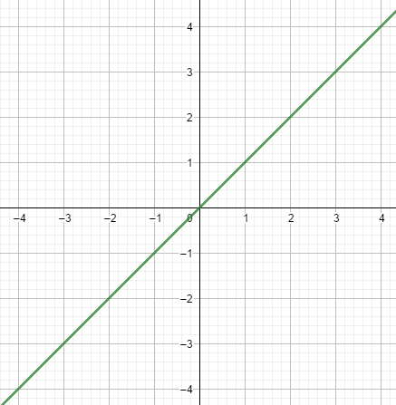 | $$y=x+3$$  How do we move?  x-int: y-int:  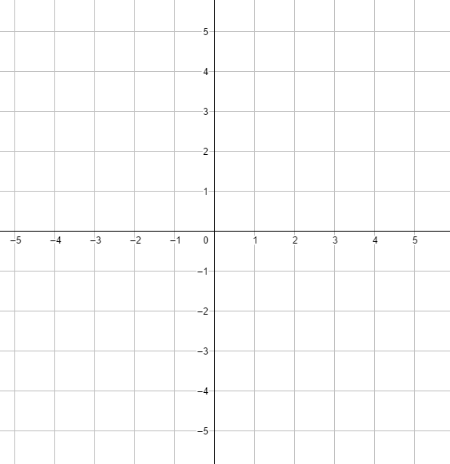
$$y=(x-1)$$  How do we move?  x-int: y-int: | $$y=x-5$$  How do we move?  x-int: y-int:
$$y=2x$$  How do we move?  x-int: y-int: | $$y=-x$$  How do we move?  x-int: y-int:
$$y=\frac{1}{3}\left(x+3\right)-1$$  How do we move?  x-int: y-int: | $$y=-4x+4$$  How do we move?  x-int: y-int:

Compare linear to quadratics. How are these similar? How are they different?
$$y=\frac{1}{2}\left(x+3\right) y=\frac{1}{2}(x+{3)}^{2}$$

$$y=-x-3 y=-x^{2}-3$$

$$y=5\left(x+4\right)+2 y=5{(x+4)}^{2}+2$$

$$y=\left(x-19\right) y={(x-19)}^{2}$$

What happens to a line when there is a number higher than 1 for a slope?

What happens to a line when there is a number lower than 1 for a slope?

Write the equations for the following specific scenarios.
- A quadratic that has been shifted 1 unit to the right and 5 units down.

- A line that has been reflected and moved up 6 units.

- A line that has been vertically stretched by a factor of 4 and moved left 4 units.

- A quadratic that has been reflected over the x-axis, vertically shrunk by ¼ and moved down 6 units.

- A quadratic that has been moved 4 units left and 9 units up.

- A line that has been translated 6 units right and 3 units down.

- A quadratic that has been vertically stretched by a factor of 7 and moved 3 units right.

- A line that has been horizontally stretched by $\frac{2}{3}$.

- A line that has been reflected, vertically stretched by a factor of 7 and down 9 units.

