GSE Algebra 1 7.4 – notes Name: _______________

Vertex vs. Standard vs. Intercept forms

Vertex form Standard form Intercept form

Given the following scenario, create the equation in vertex form.
- You are ordering a quilt for a family member. The length of the square is reduced by 3 and then you add a little piece of fabric at the end that is 4 square meters.

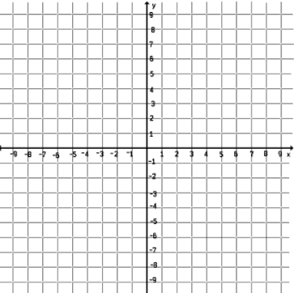
Describe the shifts that have happened to this equation. Graph it.

Now let’s look at this equation. $y=x^{2}-6x+9$ What form is this?

Let’s convert it to vertex form using $x=-\frac{b}{2a}$

Graph it here.

Convert the following into vertex form. Convert the following into standard form.
$y=x^{2}+4x+2 y=3(x-3)^{2}-7$

What form is the equation below in?
$$y=(x-1)(x+3)$$

Convert it to standard form.

Then convert it to vertex form. Graph it here.

Try this one.
What form is this one in? $y=2(x-2)(x-6)$

Convert it to standard form. Then convert it to vertex form.

Write out vertex form. Write out standard form. Write out intercept form.

Label what form each one is in.
- $y=-3(x-1)^{2}+4$ 2) $y=-(x+3)(x-4)$ 3) $y=\frac{1}{2}x^{2}-4x+3$

Convert from vertex form to standard form.
- $y=2(x+3)^{2}-3$ 5) $y=-\frac{1}{4}(4x-4)^{2}$ 6) $y=-(x-7)^{2}+5$

Convert from standard form to vertex form.
- $y=4x^{2}-16x-1$ 8) $y=-\frac{1}{2}x^{2}+4x$ 9) $y=x^{2}-7x+3$

Convert from intercept to standard form.
- $y=3(x-1)(x+3)$ 11) $y=-(x+2)(x+3)$ 12) $y=\frac{1}{3}(3x-9)(x+5)$

Where has each graph moved? List out all the transformations.
- $y=\frac{1}{3}(x-1)^{2}-3$ 14) $y=-4(x+2)^{2}$ 15) $y=-(x-10)^{2}+3$ 16) $y=x^{2}-4$

Let’s graph some.
- $y=3(x-2)^{2}-4$

- $y=-(x+1)(x-3)$

- $y=\frac{1}{2}x^{2}-4x+3$

