GSE Algebra 1 **7.3 – notes** Name: _______________

Graphing in standard form.

What is the equation for vertex form: Equation for standard form:

Let’s multiply through to get into standard form.

1. $f\left(x\right)=4(x-2)^{2}-3$ 2) $f\left(x\right)=-(x+3)^{2}+2$ 3) $f\left(x\right)=\frac{1}{2}(x+1)^{2}$

Now let’s look at a problem in vertex form and standard form.

$f\left(x\right)=(x-1)^{2}-3$

What form:

List out all the information needed to graph.

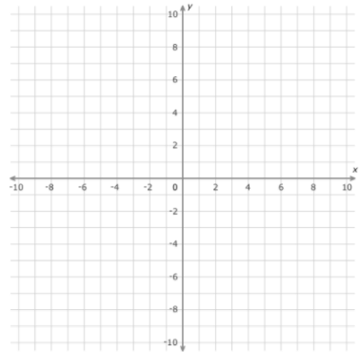

Let’s look at this problem. $f\left(x\right)=x^{2}-2x-2$ Can you easily find the vertex here?

**Let’s list out the a, b and c for the equation above.**

**a: b: c:**

We need to use $x=-\frac{b}{2a}$

Let’s find the x – value of the vertex 1st. (**H**) Then substitute x into the equation to find the y – value. (**K**)

Find **a.**  Now let’s create the vertex form equation: $y=a(x-h)^{2}+k$

How does this equation compare to the previous problem? Same? Different?

Let’s try some more. We are going to convert from **STANDARD** **FORM** to **VERTEX** **FORM** (so we can **GRAPH**).

1. $y=-4x^{2}-8x+7$ 2) $y=\frac{1}{2}x^{2}+10x-1$ 3) $y=x^{2}+6$



1. $y={-x}^{2}-2x$ 5)  6) 



**BIG PROBLEM!**

$$y=(x-2)(x-4)$$

Let’s list out the information we know.

x-ints: standard form: y-int:

Convert to vertex form from standard form above.



List all the shifts that occur. Now graph it!