GSE Algebra 1 7.2 – notes Name: ____________

We are going to practice writing equations in vertex form using all different pictures.

Let’s talk about how these have moved on the graph.
- ${f\left(x\right)=(x-1)}^{2}+3$ 2) $f\left(x\right)=-4(x+3)^{2}$

- $f\left(x\right)=\frac{1}{3}x^{2}+10$ 4) $f\left(x\right)=-(x+5)^{2}-7$

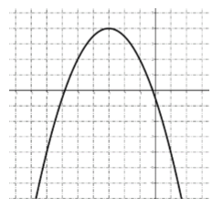
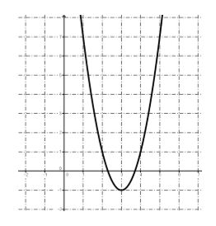
Let’s make equations now given all different types.
- 6)

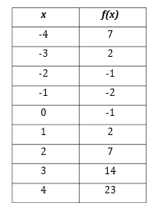
The area of a square with side length x, where the side length is decreased by 3, the area is multiplied by 2 and then 4 square units are added to the area.
- 8)

Let’s graph the following in vertex form based off the knowledge you have.
- $f\left(x\right)={-x}^{2}+3$ 10) $f\left(x\right)=(x+2)^{2}-5$
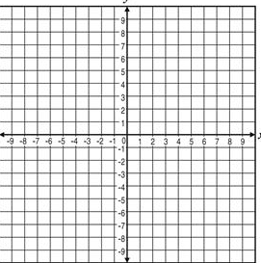

- $f\left(x\right)=3(x-{1)}^{2}+2$ 12) $f\left(x\right)=\frac{1}{2}x^{2}-6$

