GSE Algebra 1 7.1 – Notes Name: ___________________
The goal here to see what happens to parabolas as we move them around a graph, what happens in the equation and how that can affect the tables.

Let’s look at quadratics again. What shape do they make? _________________

Match the correct statement to the description below.
Matching Equation  (A, B, C, or D) | Statement | Function Equation
 | The length of each side of a square is increased by 5 units. | A | $$A\left(x\right)={5x}^{2}$$
 | The length of each side of a square is multiplied by 5 units. | B | $$A\left(x\right)=(x+5)^{2}$$
 | The area of a square is increased by 5 square units. | C | $$A\left(x\right)=(5x)^{2}$$
 | The area of a square is multiplied by 5. | D | $$A\left(x\right)=x^{2}+5$$

What is the domain of $y=x^{2}$? PARENT FUNCTION: $y=x^{2}$

Let’s look at how each part above changes the graph, equation and table.

$$y=x^{2}+5$$
How has this changed from the parent function $y=x^{2}$?
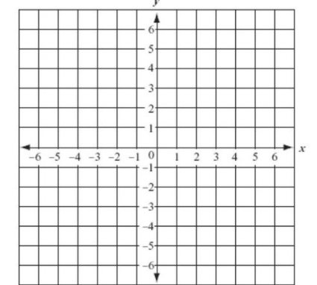
Equation Table Graph
$$y=x^{2}$$ | $$y=x^{2}+5$$
$$y=x^{2}$$ |  | $$y=x^{2}+5$$
x | y | x | y
-2 |  | -2
-1 |  | -1
0 |  | 0
1 |  | 1
2 |  | 2
3 |  | 3

Let’s look at a few more. Try these two based off the work from above.

- $y=x^{2}+2$ b) $y=x^{2}-3$

So the number OUTSIDE of the parentheses

(in the back of the equation) makes the

parabola move _________ or ___________

Now let’s try this one:
$$y=(x+5)^{2}$$
Equation Table Graph
$$y=x^{2}$$ | $$y={(x+5)}^{2}$$
$$y=x^{2}$$ |  | $$y={(x+5)}^{2}$$
x | y | x | y
-2 |  | -7
-1 |  | -6
0 |  | -5
1 |  | -4
2 |  | -3
3 |  | -2

Let’s look at a few more. Try these two based off the work from above.

- $y={(x+2)}^{2}$ b) $y={(x-3)}^{2}$

So the number INSIDE of the parentheses

(in the middle of the equation) makes the

parabola move _________ or ___________

Now this one:
$$y=5x^{2}$$
Equation Table Graph
$$y=x^{2}$$ | $$y={5x}^{2}$$
$$y=x^{2}$$ |  | $$y={5x}^{2}$$
x | y | x | y
-2 |  | -2
-1 |  | -1
0 |  | 0
1 |  | 1
2 |  | 2
3 |  | 3

Now try these two:
x | -2 | -1 | 0 | 1 | 2 | 3
y
- $y=\frac{1}{4}x^{2}$ b) $y={2x}^{2}$
x | -2 | -1 | 0 | 1 | 2 | 3
y

Let’s look at what happens when the parabola is flipped upside down.
$$y=-x^{2}$$
Equation Table Graph
$$y=x^{2}$$ | $$y={-x}^{2}$$
$$y=x^{2}$$ |  | $$y={-x}^{2}$$
x | y | x | y
-2 |  | -2
-1 |  | -1
0 |  | 0
1 |  | 1
2 |  | 2
3 |  | 3

So what happens when the number in front of the x² is negative?

This is called a ____________________ over the x-axis.

Bringing it ALL together!

The vertex form of a quadratic is all of what you just did put together.
$y=a(x-h)^{2}+k$ Vertex: (h, k)
What does each part mean?
a | If a is positive | If a is negative | If a > 1 | If 0 < a < 1
h | If h is positive in the equation |  | If h is negative in the equation
k | If k is positive in the equation |  | If k is negative in the equation

Tell what has happened just based on the equation.
- $y=4(x-1)^{2}+3$ 2) $y=-(x+3)^{2}-2$ 3) $y=\frac{1}{3}x^{2}-3$ 4) $y=-10(x+2)^{2}$

