GSE Algebra 1 **6.6 Notes** Name: _________________

For each problem given, tell all of the following:

* Function or not
* Whether it is linear, quadratic, exponential or none of the above.
* Describe how each graph is growing (moving)
* Create at least one way to represent it (graph, table, picture, equation)

1. A plumber charges a base fee of $55 for a service call plus $35 per hour for each hour worked during the service call. Figure out the relationship between the total price of the service call and the number of hours worked



Dom: Range: max/min:

Y-int: Vertex: A.O.S.:

Incr: Decr: Direc:

End Beh: $x→-∞ y→$ Disc/Cont?

$x→∞ y→$

1. 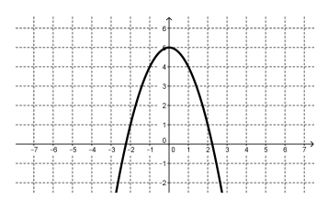
2. 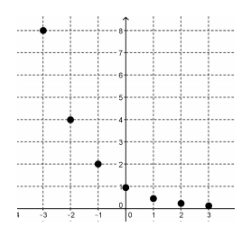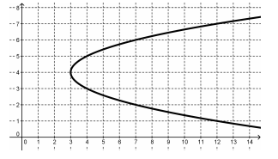 4)



1. 
2. The relationship between the speed of a car and the distance it takes to stop when traveling at that speed.

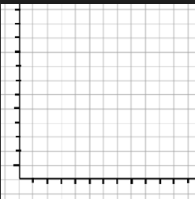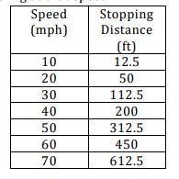

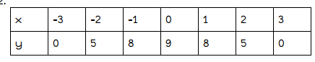

1. 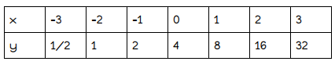 8)

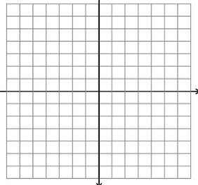

Rate of change: Rate of change:

10) 

1. 





1. Mary Bo Peep wants to build a rectangular flower garden surrounded by a walkway 4 meters wide. The flower garden will be 6 meters longer than it is wide.
   1. What is the relationship between the width of the garden and the perimeter of the walkway?
   2. What is the relationship between the width of the garden and area of the walkway?

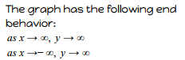

1. 13)

