GSE Algebra 1 HW #6.4 Name: ___________________

Calculate the slope of the line between the given points. Use your answer to indicate which line is the steepest.
(Find the larger number and tell which one is steeper)

- A (-3, 7) B (-5, 17) 2) H (12, -37) K (4, -3)

Indicate which function on the graph has a higher rate of change (which one is increasing at a faster rate).
- 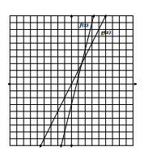 4) 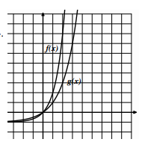

- For the following graph, which function has a higher rate of change over the interval from x = 0 to x = 2.5.
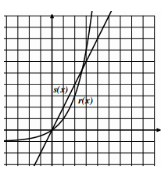
What happens after the two graphs intersect?

Which function takes over that has a higher rate of change?

- List out all the characteristics of the function and graph given below.
$y=(x+1)(x-5)$
Vertex: Dom: Range:

Direction: Max/Min y-int:

x-ints: Increase: Decrease:

axis of symm: End Beh: $x→-∞ y→$
$x→∞ y→$

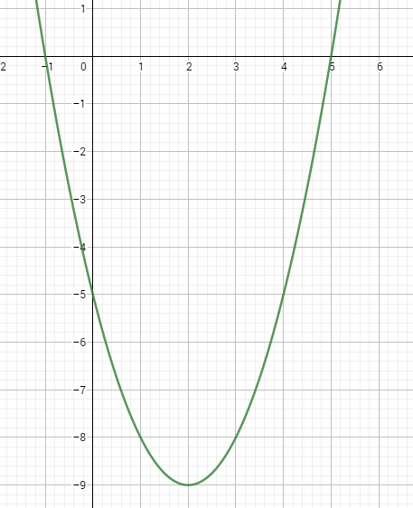
Write the equation above in standard form.
Solve the equation above for the x-intercepts.

