GSE Algebra 1 6.3 – 6.4 Notes Quadratics Name: _______________

You have a new bunny, Fluffy. You want to build a pen for Fluffy so that she can roam around and not bother you. You bought 72 feet of fencing to build a rectangular pen.

Length  x | Width | Area  A(x)
1 | 35
- Draw a picture of a rectangular pen. Then think of some possible dimensions for the perimeter that can add up to 72 feet. You have a table to fill in to help you out.

- With the dimensions that you just filled in, find the area for each play pen for your bunny. Fill in the area part of the chart.
**Remember, length x width is area.

- Which option that you have provided gives you the largest area?

- Let’s think of a model using x that we could create to use to find the area of the pen if we did not know that length or width of the play pen. Think about quadratics, we know that they have to have an exponent of 2.

Graph the equation here.

Let’s list out all the info that we know:

Dom: Range:

y-int: x-ints:

Vertex: Max/min:

axis of symm: Direction:

Inc: Dec:

Let’s look at more characteristics of Quadratics.
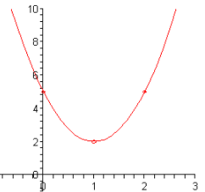
Vertex: Axis of symm: y-int:

x-ints: Dom: Range:

Direction: Max/Min: Increasing:

Decreasing: End Behavior: $x→-∞ y→$
$x→∞ y→$
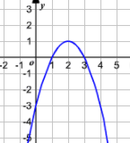
Vertex: Axis of symm: y-int:

x-ints: Dom: Range:

Direction: Max/Min: Increasing:

Decreasing: End Behavior: $x→-∞ y→$
$x→∞ y→$
$$y=-(x-5)(x+1)$$
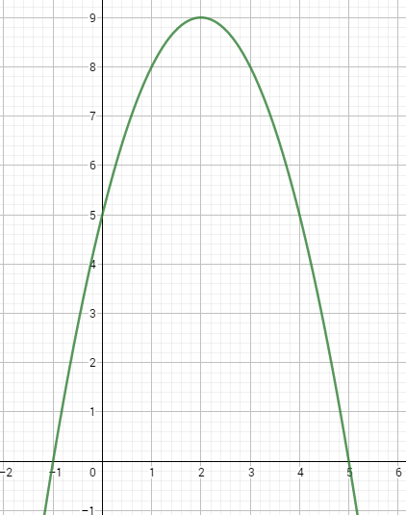
Put the above equation in standard form.
Vertex: Axis of symm: y-int:

x-ints: Dom: Range:

Direction: Max/Min: Increasing:

Decreasing: End Behavior: $x→-∞ y→$
$x→∞ y→$
Look at the following equations. List out what you know based just on the equations.
- $y=\left(x-3\right)\left(x-7\right)$ b. $y=2(x+2)(x-6)$ c. $y=\frac{1}{2}x(x+4)$

