GSE Algebra 1 HW #6.2 Name: _________________

Simplify the following. Be sure to show how you do it!
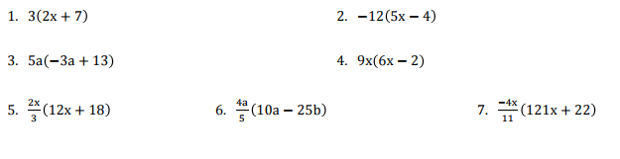
$$x\left(3x+4\right)-5(3x-4)$$

$$2x\left(5x+3\right)+7(5x+3)$$

7) Label the following tables as linear, exponential or quadratic. 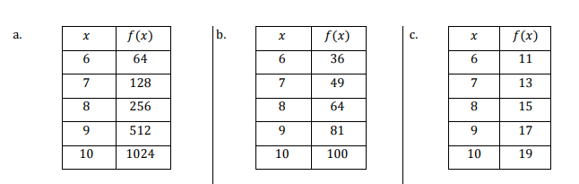
8) Graph letter C.

10) Graph letter F.
9) Label the following tables as linear, exponential or quadratic.
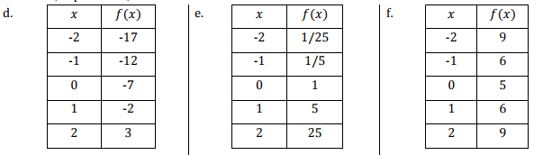

Find the rate of change (SLOPE) for each below.
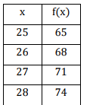
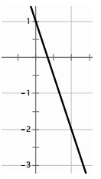
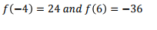
11) 12) 13)

14) George is loading a freight into an elevator. He notices that the weight limit for the elevator is 1000 lbs. He knows that he weighs 210 lbs. He has loaded 15 boxes into the elevator. Each box weighs 50 lbs.

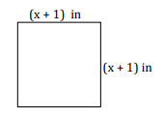
- Find the area and the perimeter of the following shapes. Be sure you write your units correctly.
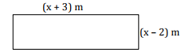
- Perimeter: ______________
- Area: _____________
- Perimeter: ______________
- Area: _____________

- How are the perimeters and the areas in the problems above different?

