Quadratics – let’s break it down 6.2-6.3 Part 2

Look at the table – what kind is it?
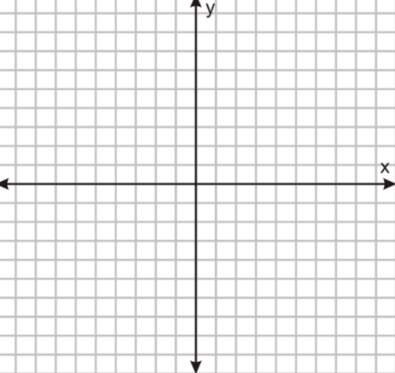
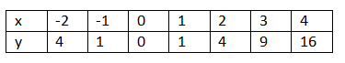
Graph it over here

What shape is this similar to?

We call these ______________________

**Here are what parabolas have
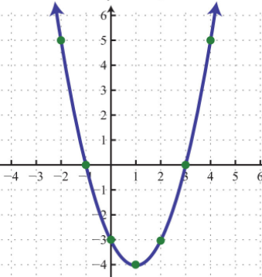
Vertex: y-intercept:

direction: x-intercepts:

maximum or minimum: axis of symmetry:

Domain: Range:

Function? Discrete or cont?

- Quadratics will always have an exponent of _______________

If it’s a 2 it’s a U!

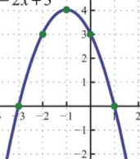
Vertex: Axis of symmetry: Function?

y-intercept: x-intercepts: Domain:

Direction: Max or min? Range:

Increasing: Decreasing: Disc/Cont

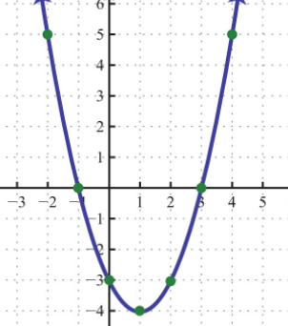
Vertex: Axis of symmetry: Function?

y-intercept: x-intercepts: Domain:

Direction: Max or min? Range:

Increasing: Decreasing: Disc/Cont

$$f\left(x\right)=(x-1)(x+3)$$
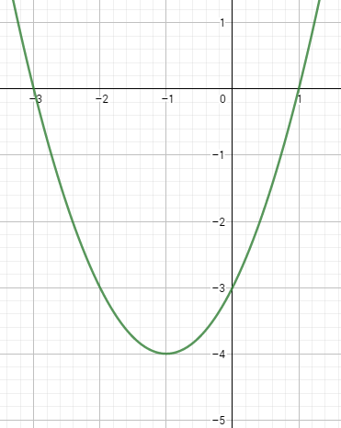
Vertex: Axis of symmetry: Function?

y-intercept: x-intercepts: Domain:

Direction: Max or min? Range:

Increasing: Decreasing: Disc/Cont

What do you notice about the graph vs. the function?

*Quadratics are always _________________ and are always _______________________

